Drawing Views
Understands that 3-D objects can be represented in 2-D with  different views.  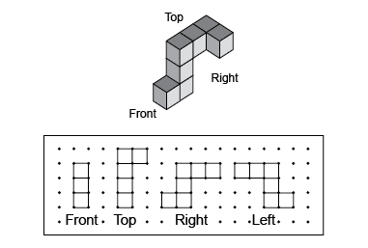  “3-D objects can be represented on paper to show different views. I can match the object to the different views by laying the object on top of the views.” | Draws top, front, and side views of objects and matches views to a  3-D object.  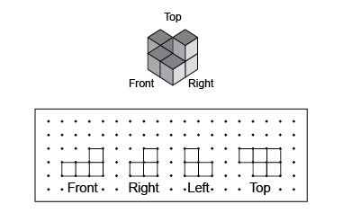  “I used square dot paper to draw and label each view and match the object to the drawings.” | Constructs a 3-D object using  given views.  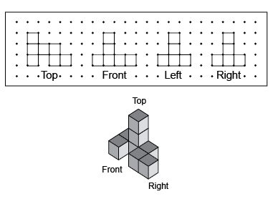  “I constructed a 3-D object using the views. I started with the top view, then added the front view. Each additional view provided more information for building the  3-D object.” | Analyzes multiple 3-D objects from different perspectives using the same views.  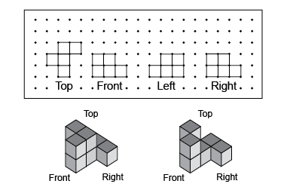  “I visualized and built more than one 3-D object from the set of views (e.g., a cube can sometimes be placed behind other cubes without changing the views). When I change the orientation of the object, the perspective changes the views.”
Observations/Documentation

