Investigating Polygons
Recognizes a polygon as a closed shape with straight lines.  “I know these are polygons because they are closed shapes with straight sides.” | Understands that regular polygons have equal sides and equal angles.  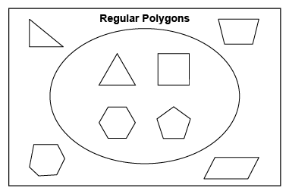  “The shapes inside the loop are regular polygons because they have equal sides and equal angles.” | Describes differences and similarities between regular and irregular polygons.  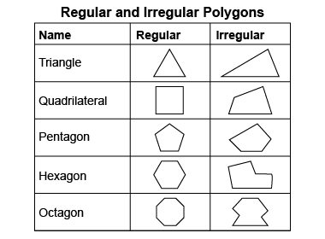  “The polygons in the second row are both quadrilaterals because they both have 4 sides. The square is a regular polygon because it has 4 equal sides and 4 equal angles, but the other quadrilateral is irregular because it does not  have any equal sides.” | Flexibly identifies and classifies polygons.  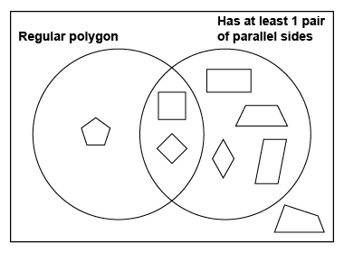  “I sorted the polygons using the Venn diagram. The irregular quadrilateral is outside of the loops because it has neither attribute.”
Observations/Documentation

