Fractions, Decimals, and Percents on a Probability Line
Represents the theoretical probability of events happening using words on a probability line.  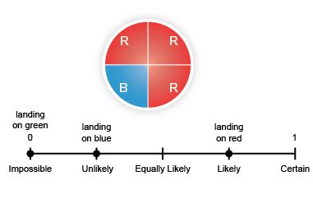  “I know that since no sector on the spinner is green, the likelihood of landing on green is impossible.” | Represents the theoretical probability of events happening using fractions and percents on a probability line.  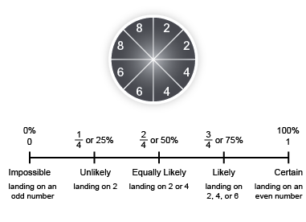  “Since 2 of the 8 sectors have “2”, the likelihood of landing on 2 is $\frac{1}{4}$ or 25%. I placed it one-fourth of the way along the line.” | Represents the theoretical probability of events happening using fractions, decimals, and percents, and uses benchmarks to place them on a probability line.  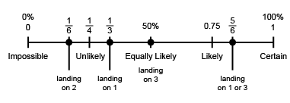  “The likelihood of landing on 2 is $\frac{1}{6}$, which is between 0 and $\frac{1}{4}$,  but closer to $\frac{1}{4}$.” | Flexibly represents probabilities on a probability line and analyzes data to make predictions and informed decisions about experimental results.  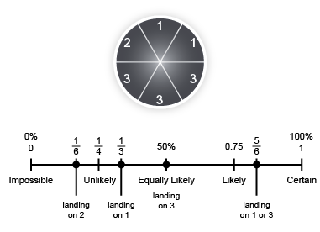  “I predict that if the spinner was spun 600 times, it would land on 2 about 100 times.”
Observations/Documentation

