Creating and Interpreting Graphs
Uses common attributes (basic shape, scale, titles, and labels) to create different graph types.  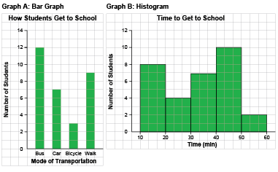  “I created a bar graph and a histogram about getting to school.” | Chooses graph types based on the data (e.g., line graphs, histograms) and justifies choice.  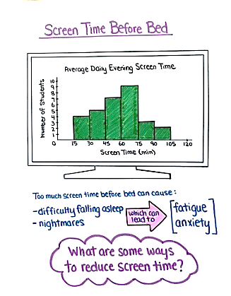  “I created a histogram to show the amount of screen time students have in the evening. Since my audience is Grade 6 students, I made the graph look more fun and engaging by drawing the histogram in a TV screen.” | Uses graphs to answer some questions within and beyond the data.  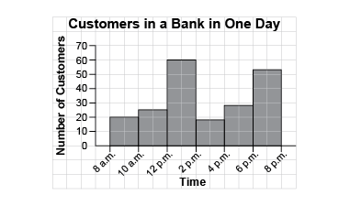  “I drew lines to find how old Benji was when he was 80 cm tall: about 2 years 9 months. I assumed Benji continued to grow at the same rate and estimated he would be about 125 cm tall at  age 11.”
Observations/Documentation

Creating and Interpreting Graphs (cont’d)
Uses attributes of graph and measures of central tendency to draw some conclusions.  Brad had these practice times, in seconds, for the 400-m sprint: 73, 64, 55, 81, 68, 62, 57, 64  “I determined the range: 26; mode: 64; median: 64; mean: 65.5. Brad’s average practice time is about 64 s.” | Analyzes data, draws conclusions, and makes convincing arguments.  “I would use the data to convince the bank to have more staff on between 12 noon and 2 p.m. and between 6 p.m. and 8 p.m. as that is when the bank is busiest.” | Fluently solves problems by graphing data and interpreting the results.  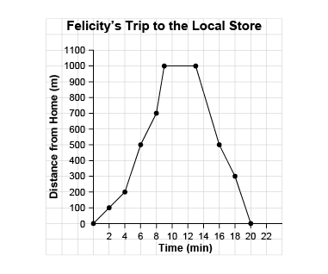  “From the graph, I see Felicity spent 4 minutes at the store as her distance from home  did not change.”
Observations/Documentation

Collecting and Organizing Data
Recognizes the difference between first- and second-hand data.  “I measured the height of the tomato plant daily, so that is first-hand data. I got the heights of the basketball players from the Internet, so that is second-hand data.” | Formulates questions to help with data collection.  “I wanted to find my classmates’ favourite raw vegetable. I asked: What is your favourite raw vegetable: cauliflower, broccoli, celery, carrot, cucumber, other?” | Chooses best method to collect data (e.g., first- or second-hand data, survey vs experiment, databases vs electronic media).  “To find out what people think about the renovations to the community centre, I would collect first-hand data using a questionnaire.”
Observations/Documentation

Collecting and Organizing Data (cont’d)
Chooses representative sampling technique to collect relevant data (e.g., simple/systematic random, stratified).  “I can’t survey everyone who enters the community centre. I will use systematic random sampling and survey every 10th person.” | Represents collected data using appropriate organizers.  “I would display the data in a bar graph so that it is easy for others to see how satisfied the community is with the renovations.” | Uses collected data to draw conclusions and make informed decisions.  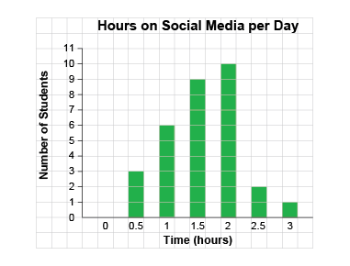  “This graph tells me that more of my Grade 6 classmates spend between 1.5 h and 2 h a day on social media. This is a sample of the Grade 6 students and is not representative of all Grade 6 classes across Canada.”
Observations/Documentation

