Creating and Interpreting Graphs
Uses common attributes (basic shape, scale, titles, and labels) to create different graph types.  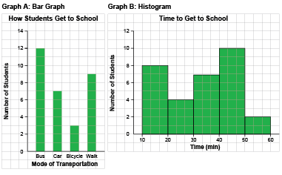  “I created a bar graph and a histogram about getting to school.” | Chooses graph types based on the data (e.g., line graphs, histograms) and justifies choice.  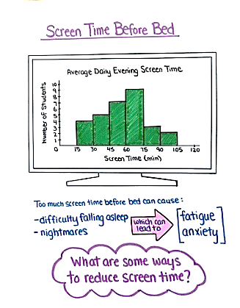  “I created a histogram to show the amount of screen time students have in the evening. Since my audience is Grade 6 students, I made the graph look more fun and engaging by drawing the histogram in a TV screen.” | Uses graphs to answer some questions within and beyond the data.  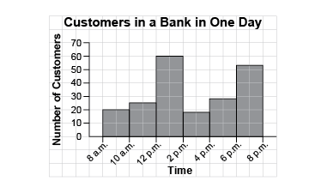  “I drew lines to find how old Benji was when he was 80 cm tall: about 2 years 9 months. I assumed Benji continued to grow at the same rate and estimated he would be about 125 cm tall at  age 11.”
Observations/Documentation

Creating and Interpreting Graphs (cont’d)
Uses attributes of graph and measures of central tendency to draw some conclusions.  Brad had these practice times, in seconds, for the 400-m sprint: 73, 64, 55, 81, 68, 62, 57, 64  “I determined the range: 26; mode: 64; median: 64; mean: 65.5. Brad’s average practice time is about 64 s.” | Analyzes data, draws conclusions, and makes convincing arguments.  “I would use the data to convince the bank to have more staff on between 12 noon and 2 p.m. and between 6 p.m. and 8 p.m. as that is when the bank is busiest.” | Fluently solves problems by graphing data and interpreting the results.  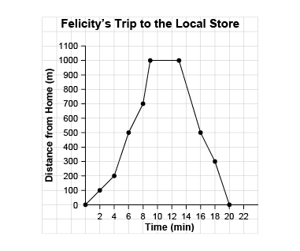  “From the graph, I see Felicity spent 4 minutes at the store as her distance from home  did not change.”
Observations/Documentation

