Collecting and Organizing Data
Recognizes the difference between first- and second-hand data.  “I measured the height of the tomato plant daily, so that is first-hand data. I got the heights of the basketball players from the Internet, so that is second-hand data.” | Formulates questions to help with data collection.  “I wanted to find my classmates’ favourite raw vegetable. I asked: What is your favourite raw vegetable: cauliflower, broccoli, celery, carrot, cucumber, other?” | Chooses best method to collect data (e.g., first- or second-hand data, survey vs experiment, databases vs electronic media).  “To find out what people think about the renovations to the community centre, I would collect first-hand data using a questionnaire.”
Observations/Documentation

Collecting and Organizing Data (cont’d)
Chooses representative sampling technique to collect relevant data (e.g., simple/systematic random, stratified).  “I can’t survey everyone who enters the community centre. I will use systematic random sampling and survey every 10th person.” | Represents collected data using appropriate organizers.  “I would display the data in a bar graph so that it is easy for others to see how satisfied the community is with the renovations.” | Uses collected data to draw conclusions and make informed decisions.  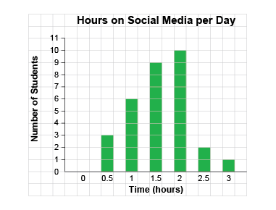  “This graph tells me that more of my Grade 6 classmates spend between 1.5 h and 2 h a day on social media. This is a sample of the Grade 6 students and is not representative of all Grade 6 classes across Canada.”
Observations/Documentation

