Calculating Percents using Mental Math
Explores number patterns and relationships.  100% of 360 = 360  50% of 360 = 180  25% of 360 = 90  12.5% of 360 = 45  What patterns do you see?  “I see that the percent is halved each time and when this happens, the product is also halved.”  (« Je vois que le pourcentage est réduit d’une moitié chaque fois et lorsque cela se produit, le produit est également réduit d’une moitié. ») | Uses number patterns and relationships to solve problems.  50% of 80 = ?  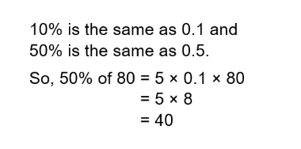 | Uses mental math strategies and checks for reasonableness.  Find 14% of $300  14% = 10% + 5% – 1%  10% of $300 = $30  5% of $300 = $15  1% of $300 = $3  So, 14% of $300 = $30 + $15 – 3  = $42 | Fluently calculates percents using a variety of mental math strategies.  8% of 260 = ?  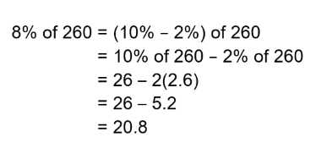
Observations/Documentation

