Extending Patterns to Solve Problems
Determines the pattern rule.  100, 97, 91, 86, 70, 55, 37, 16  “The pattern rule is: Start at 100 and subtract 3. Increase the number subtracted by 3 each time.” | Uses pattern rule to determine missing values.  How would you determine the missing value for week 5?  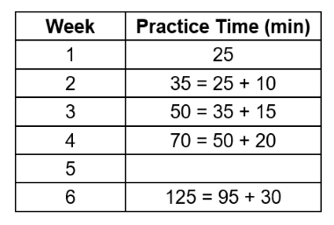  “The pattern rule is: Start at 25 and add 10. Then increase the amount added by 5 each time.  Week 5 is 70 + 25 = 95.” | Extends patterns using mathematical expressions.  3, 8, 13, 18, 23, 28  “I can use the expression  5n – 2 to extend the pattern, where n represents the term number.  The seventh term would be  5 × 7 – 2 = 33.” | Flexibly describes and solves problems using mathematical expressions and properties.  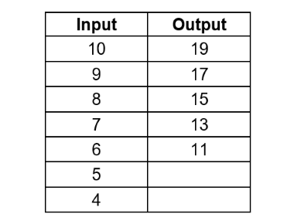  “To determine the output number, multiply the input number by 2 and subtract 1. I would use the expression 2n – 1, where n is the term number, to find the missing values:  2 × 5 – 1 = 9, 2 × 4 – 1 = 7.”
Observations/Documentation

