Problem Solving with Money (Including Sales Tax)
Recognizes prices involving dollars and cents and identifies which items require sales tax.  “The price of a bag of apples  is $3.85.  Apples don’t have sales tax added.”  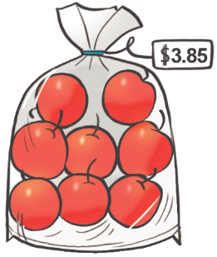 | Estimates the cost of transactions involving several items, including sales tax.  “I made friendly numbers to estimate the total cost: $10 + $10 + $46 = $66. Then for tax, 10% is about $7 and 3% is about $2. The total cost is about $75.”  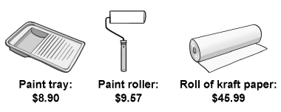 | Calculates the cost of several items with prices in dollars and cents, including sales tax.  “I made friendly numbers:  $8.90 + $9.57 + $45.99  = $9 + $9.46 + $46  = $64.46.  Then I used a calculator and multiplied by 1.13 to get total cost including tax: $72.84.” | Uses mental math strategies to estimate, calculate total cost including sales tax, and determine change  “To find the change from a $100 bill, I would add on from $72.85 as the amount would be rounded to the nearest 5¢.  $72.85 + $0.15 =$73.00  $73 + $7 = $80  $80 + $20 = $100  $0.15 + $7 + $20 = $27.15.”
Observations/Documentation

Designing a Basic Budget
Identifies a financial goal.  “I want to save enough money to buy a new bicycle.” | Considers some factors involved in designing a budget.  “I know it is important to consider how much money I earn, and how I spend money.” | Designs a basic budget recognizing the importance of several factors  “I know that I need to think about when I need the money, other jobs that I can do to earn more money, and any expenses that I have.” | Applies key factors to design a basic budget to manage finances and inform decisions.  “I want to buy a new bicycle in 2 months. I can walk my neighbour’s dog to earn more money, but I need to pay back $5 a week to my Mom.”
Observations/Documentation

