Finding Best Value
Identifies the better value by comparing prices of two sizes of the same product.  “The 2-L size is the better value because it is costs just a little more than the 1-L size and you get twice as much juice.”  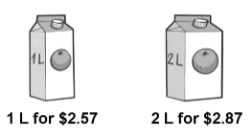 | Identifies the better value by comparing the unit rates for two options of same product.  “I divided the price by the number of bars in each package to get the price of one bar.  $2.98 ÷ 6 is about $0.50 and  $4.47 ÷ 10 is about $0.45.  The package of 10  is the better value.”  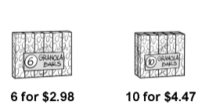 | Identifies the best value by comparing unit rates for several options of the same product.  “Option A: $2.98 ÷ 6 is about $0.50.  Option B: $4.47 ÷ 10 is about $0.45.  Option C: $10.49 ÷ 24  is about $0.44.  Option C is the best value.”  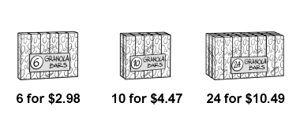 | Identifies the best value and realizes that the best value is not always the best option.  “The best value is the box of  24 granola bars, but I live alone and 24 bars is too many for me.  They would go to waste.”
Observations/Documentation

