Credit, Debt, and Transfers
Identifies ways money can be transferred.  “I can transfer money in many ways such as using cash, a debit card, a gift card, and an e-Transfer.”  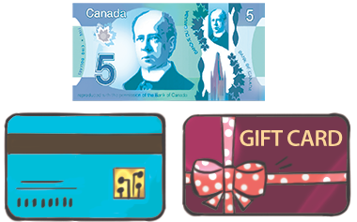 | Explains the difference between credit and debt.  “Credit is the ability to borrow money, while debt is the result of borrowing money.” | Identifies a situation as involving credit or debt and provides reasoning.  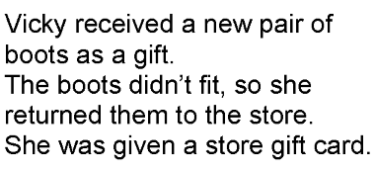  “It involves credit because the store put money on a card that I can apply later to another purchase. I have money available to use.” | Creates situations involving credit or debt and understands the impact of financial decisions  “We needed a car, so my dad took out a loan to pay for it as we didn’t have enough money in the bank. We went into debt.”
Observations/Documentation

