Multiplication and Division with Unit Fractions
Recognizes multiplication and division situations.  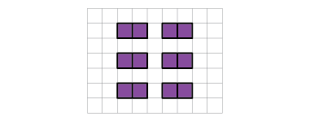  “I see multiplication: 12 parts of one half.  I also see division:  6 wholes divided into one-half parts.” | Writes an equation to represent a multiplication or division situation.  “I can represent this situation using a multiplication and a division equation.”  12 × $\frac{1}{2}$ = 6; 6 ÷ $\frac{1}{2}$ = 12 | Models situations involving a whole partitioned into unit fractions in many ways.  3 ÷ $\frac{1}{3}$ = ?  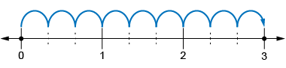  “I used a number line from 0 to 3, partitioned each whole into thirds, then counted the thirds: 1 one-third, 2 one-thirds, 3 one-thirds, …, 8 one-thirds, 9 one-thirds. 3 ÷ $\frac{1}{3}$ = 9.”
Observations/Documentation

Multiplication and Division with Unit Fractions (cont’d)
Solves equations using addition or subtraction.  6 × $\frac{1}{5}$ = ?  “I added $\frac{1}{5}$ 6 times: $\frac{1}{5}$ + $\frac{1}{5}$ + $\frac{1}{5}$ + $\frac{1}{5}$ + $\frac{1}{5}$ + $\frac{1}{5}$ = $\frac{6}{5}$” | Solves using the properties of multiplication or division, extends to a variety of contexts.  Valentina and her abuela are making empanadas. They used $\frac{1}{3}$ of the recipe and the recipe called for 6 cups of flour.  How much flour did they need?  “I found $\frac{1}{3}$ of 6 cups: 6 × $\frac{1}{3}$ = $\frac{6}{3}$, or 2.  They needed 2 cups of flour.” | Solves multiplication and division problems flexibly, using a variety of strategies.  Ha-jun hikes $\frac{1}{2}$ km every day. How long will it be before Ha-jun has hiked 18 km?  18 ÷ 1/2 = ?  “If Ha-jun hikes $\frac{1}{2}$ km in one day, he will hike 1 km in 2 days. So, he will hike 18 km in 18 × 2 = 36 days.”
Observations/Documentation

