Representing Equivalent Ratios and Rates
Uses multiplicative relationships to represent and create ratios and rates (ratio table).  It takes 6 cups of blueberries to make a pie.  How many cups of blueberries  will I need to make 5 pies?  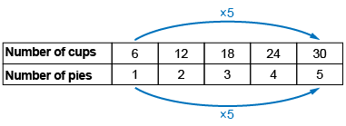  “I use a ratio table to see patterns to help me solve problems.” | Represents and records ratios and rates symbolically.  6:1, 12:2, 18:3, 24:4, 30:5 | Represents and creates equivalent ratios and rates.  The ratio of cups  of blueberries to pies is 30:5.  Identify equivalent ratios.  “I multiply or divide each term by the same number. Equivalent ratios: | Flexibly represents and creates equivalent ratios and rates.  A baker sells 2 pies for $15. How much did the baker make  if 7 pies were sold?  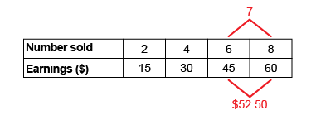  “7 is halfway between 6 and 8, so I find the number halfway between  45 and 60, which is $52.50.”
Observations/Documentation

