Exploring Fractions, Decimals, and Percents
Recognizes that equivalent fractions name the same quantity  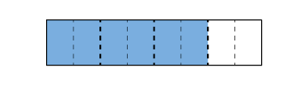  “If I partition each fourth into  2 equal parts, I see $\frac{3}{4}$ = $\frac{6}{8}$.” | Uses counting to determine improper fractions and mixed numbers  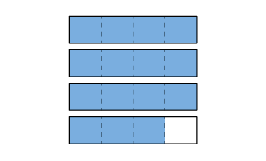  “I counted 15 one-fourths. Each four-fourths is one whole, so $\frac{15}{4}$ = 3$\frac{3}{4}$.” | Represents decimal numbers as fractions  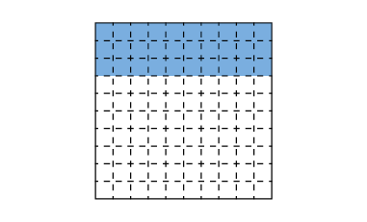  “0.3 is read three-tenths, so I shade 3 of the 10 rows on a hundredths grid and write $\frac{3}{10}$.” | Recognizes and writes equivalent decimals  “This model shows three-tenths which is the same as  thirty-hundredths.”
Observations/Documentation

Exploring Fractions, Decimals, and Percents (cont’d)
Rounds decimals to a specified place value (e.g., nearest tenth)  “2.29 is closer to 2.3 than to 2.2, so I round up to 2.3.” | Compares and orders fractions and decimals using a variety of strategies  “$\frac{5}{8}$, $\frac{8}{9}$, $\frac{2}{6}$: $\frac{5}{8}$ is a little more than $\frac{1}{2}$; $\frac{8}{9}$ is close to 1, but a little less; $\frac{2}{6}$ is close to $\frac{1}{2}$, but a little less. From least to greatest: $\frac{2}{6}$, $\frac{5}{8}$, $\frac{8}{9}$.” | Understands connection between fractions and decimals (and percents for denominators of 100)  “I know that all decimals represent fractions with a denominator of 10, 100, 1000, and they are read the same way.” | Flexibly connects quantities across number systems  “I know that $\frac{2}{5}$ is the same as four-tenths, which is the same as 0.4, 0.40, and 40%.”
Observations/Documentation

