Conceptual Meaning of Whole Number Addition and Subtraction
Recognizes addition and subtraction situations and sketches a picture to  add or subtract to 10 000.  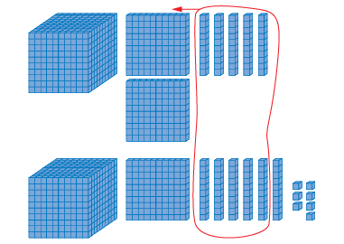  1250 + 1167 = 2417 | Models and symbolizes ways to solve problems to 10 000.  1250 + 1167 = 2417  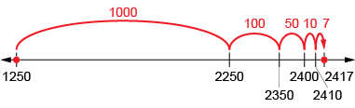 | Uses an understanding of place value to decompose both numbers to solve problems to 100 000.  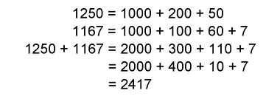  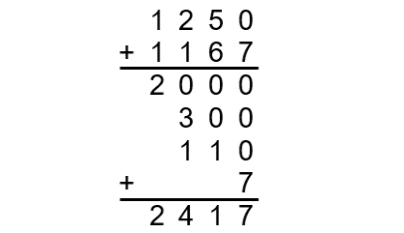  “I added the thousands, the hundreds, the tens, and then the ones.”
Observations/Documentation
 |  | .

Conceptual Meaning of Whole Number Addition and Subtraction (cont’d)
Uses an understanding of place value to decompose one number  to solve problems to 100 000.  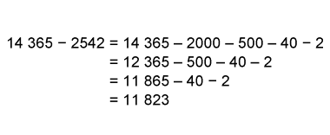 | Estimates to determine if answer to problem is reasonable.  14 365 – 2542 = 11 823  “I estimate 12 000 because  14 365 is close to 14 500,  2542 is close to 2500,  and 14 500 – 2500 = 12 000.  12 000 is close to 11 823,  so, my answer is reasonable.” | Creates and solves multi-step addition and subtraction problems flexibly using a variety of strategies.  8134 bottles were collected by the school. 4612 were donated by the community. 1645 were not accepted at the recycling depot. How many bottles were recycled?  “I added 8134 + 4612 = 12 746.  Then, 12 746 – 1645 = 11 101.  11 101 bottles were recycled.”
Observations/Documentation

