Estimating Quantities
Uses front-end estimation (focuses on first digit of number).  “This page has 263 words, so I think each page has about 200 words.” | Uses benchmarks to estimate.  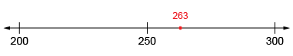  “This page has 263 words, which is close to the benchmark 250. So, every group of 4 pages  has about 1000 words.” | Gives estimate as a range.  “These pages have  263, 289, and 274 words,  so I think most pages have between 250 and 300 words.” | Uses place value understanding to round estimate (to nearest ten, hundred, or thousand).  “I estimate about 50 275 words. I can round to the nearest:  thousand: 50 000  hundred: 50 300  ten: 50 280.”
Observations/Documentation

