Using Measurement of Time
Tells time and uses benchmarks to help schedule events.  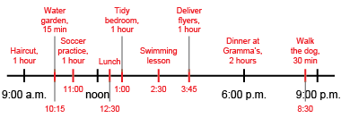  “I used a timeline to record my daily activities using benchmarks rather than exact times.” | Solves problems using elapsed time.  Buses leave at 14:15, 14:26, 14:47, and 14:58. Each trip back takes 1 hour and 11 minutes. Dara needs to be back by 3:45 p.m. Which buses can Dara take?  “I converted 3:45 p.m. to 24-hour time by adding 12 hours: 15:45. I added 1 hour and 11 minutes to each departure time to get the arrival time: 15:26, 15:37, 15:58, 16:09. Two of the buses arrive before 15:45. So, Dara can take the 14:15 or 14:26 bus.” | Uses relationships among units of time to solve problems.  It is New Year's Eve. The clock will strike midnight in 136 min. What time is it?  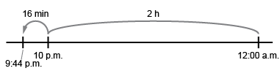  “I know 1 h = 60 min  and 2 h = 120 min.  136 min = 120 min + 16 min = 2 h and 16 min. Midnight is 12:00 a.m. The time is 9:44 p.m.” | Flexibly solves problems using various strategies and the relationships among units.  How can you use the daily cycle of the moon to help you tell time?  “There are 24 h in a day and the moon is visible for about 12 h.  Divide the sky into fourths.  For example, if the moon is about halfway across the sky, then it is about 6 hours past sundown.”
Observations/Documentation

