Investigating Volume
Chooses an appropriate unit to estimate and measure volume of object and explains reasoning.  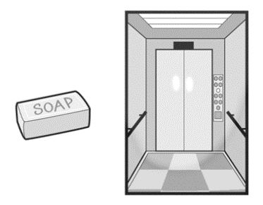  “I would use cubic centimetres for the bar of soap and cubic metres for the elevator.” | Uses benchmarks to estimate volume using metric units.  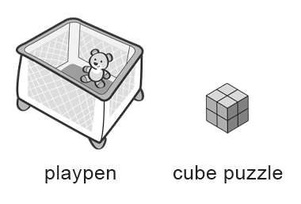  “The playpen is about 1 m³ and the cube puzzle is about 8 cm³.” | Measures the volume of objects using metric units and explains strategies.  “I covered the bottom of the box with centimetre cubes, counted the cubes in the bottom layer, then multiplied by the number of layers.”
Observations/Documentation

Investigating Volume (cont’d)
Compares and orders objects by volume using metric measures.  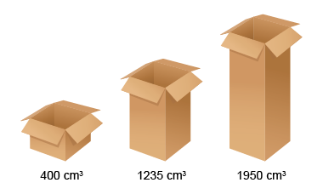  “I used centicubes to measure the volume of each box, then compared the volumes to order them from least to greatest.” | Constructs different rectangular prisms for a given volume.  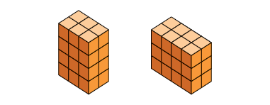  “Both of these prisms have volume 24 cm³. I made a prism with 4 layers of 6 cubes:  6 cm³ × 4 = 24 cm³. I made a prism with  3 layers of 8 cubes: 8 cm³ × 3 = 24 cm³.” | Flexibly solves problems in various contexts that involve the volume of rectangular prisms.  Kyan used 50 centimetre cubes to make a rectangular prism. There are 10 cubes in the bottom layer. How many layers of cubes does the prism have?  “There are 10 cubes in the bottom layer. I know 10 × 5 = 50, so there must be 5 layers of cubes.”
Observations/Documentation

