Measuring Area of Rectangles
Recognizes that area is measured using square units.  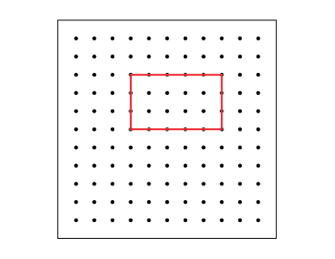  “I made a rectangle on a geoboard and used  15 square tiles to cover it.” | Determines and records area by counting squares, using square metres and/or square centimetres.  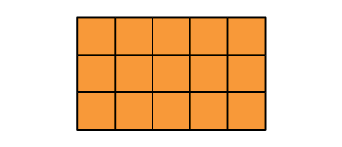  “On the grid, each square represents 1 square centimetre. There are 15 squares, so the area of the rectangle is 15 cm².” | Uses the row and column structure of an array to determine the area of a rectangle.  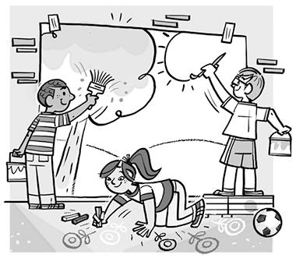  “I traced the shape on a grid and let each square represent 1 m². The rectangle forms an array with 4 rows of 6 squares: 4 × 6 = 24;  the area of the mural is 24 m².”
Observations/Documentation

Measuring Area of Rectangles (cont’d)
Constructs different rectangles for a given area (square centimetres or square metres).  Area of rectangle = 16 cm²  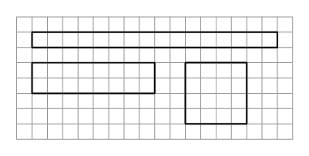  “I constructed 3 different rectangles:  A square with side length  4 cm: 4 cm × 4 cm = 16 cm².  A 2-cm by 8-cm rectangle:  2 cm × 8 cm = 16 cm²  A 1-cm by 16- cm rectangle:  1 cm × 16 cm = 16 cm²” | Chooses the more reasonable unit (square centimetres or square metres) to measure  an area.  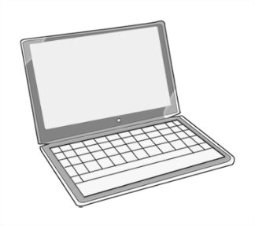  Area of laptop screen  “I would measure the area using square centimetres. I could trace the screen onto 1-cm grid paper, then multiply the number of rows by the number of columns to determine the area.” | Flexibly determines the area of rectangles, solves problems, and identifies the more reasonable square unit.  The floor has length 9 m and width 8 m. A square tile has area 1 m². How many tiles are needed to tile the floor?  “I modelled the floor on a grid. The floor has 8 rows of 9 squares: 8 × 9 = 72; area = 72 m²; so, 72 tiles are needed to cover the floor.”
Observations/Documentation

