Applying and Visualizing Rotations on a Grid
Identifies rotated 2-D shapes  on a grid.  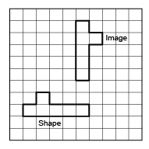  “I know the shape was rotated because the shape and its image are congruent, but the orientation  is different.” | Identifies the rotation used to move a shape and the point of rotation.  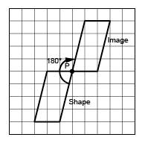  “The shape was rotated 180° about the common vertex P.” | Describes and performs rotations with angles up to 180°.  “I used tracing paper to rotate the shape 90° counterclockwise about Point Q. I labelled matching vertices with the same letter.  The vertices of the image have prime symbols.” | Visualizes, predicts, and describes where the image of a shape will be after a rotation.  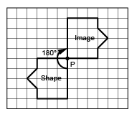  “I can picture rotating the shape in my mind. The image would face the opposite way and share Vertex P with the shape.”
Observations/Documentation

