Applying and Visualizing Translations and Reflections
Identifies translations and reflections of 2-D shapes on a grid.  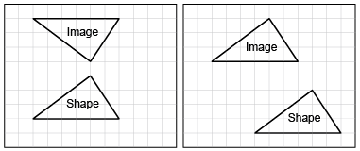  “The first image shows a reflection and the second image shows  a translation.” | Identifies the translation/reflection used to move a shape and line of reflection.  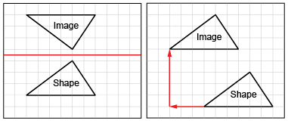  “The first shape was reflected in a horizontal line midway between the shape and its image. The second shape was translated left 3 squares and up 5 squares.” | Describes and performs translations and reflections on a grid using labelled vertices.  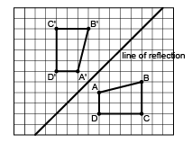  “I labelled matching vertices with the same letter. The vertices of the image have prime symbols.” | Visualizes and predicts where image of a shape will be after a translation/reflection.  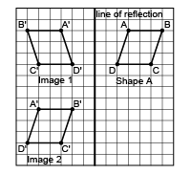  “I can picture Shape A’s reflection Image 1 on the other side of the line, with matching vertices the same distance from the line of reflection. I can picture moving Shape A left 8 squares and down 7 squares  to Image 2.”
Observations/Documentation

