Locating and Plotting Points in First Quadrant of Cartesian Plane
Uses coordinates to describe the location of points on a grid.  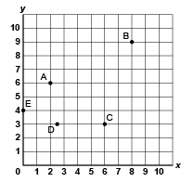  “The coordinates of Point A are  (2, 6).” | Plots and identifies points with decimal coordinates on a grid with various scales.  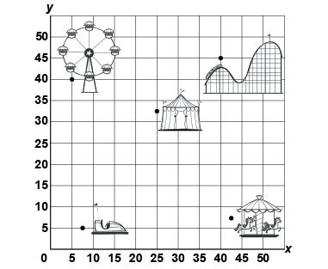  “The bumper cars are at (7.5, 5).” | Translates a point and identifies coordinates of its image.  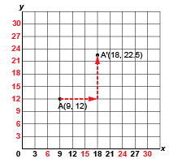  “I translated Point A right 9 units and up 10.5 units to A’(18, 22.5).” | Flexibly predicts the location and coordinates of a point after  a translation.  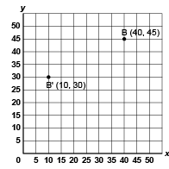  “The translation was left 30 units and down 15 units. So, I subtracted 30 from the x-coordinate and 15 from the y-coordinate:  (40 – 30, 45 – 15) B’(10, 30).”
Observations/Documentation

Applying and Visualizing Translations and Reflections
Identifies translations and reflections of 2-D shapes on a grid.  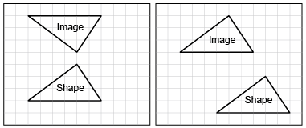  “The first image shows a reflection and the second image shows  a translation.” | Identifies the translation/reflection used to move a shape and line of reflection.  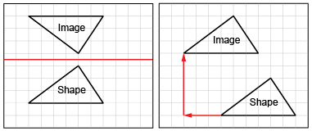  “The first shape was reflected in a horizontal line midway between the shape and its image. The second shape was translated left 3 squares and up 5 squares.” | Describes and performs translations and reflections on a grid using labelled vertices.  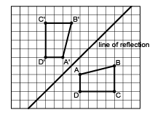  “I labelled matching vertices with the same letter. The vertices of the image have prime symbols.” | Visualizes and predicts where image of a shape will be after a translation/reflection.  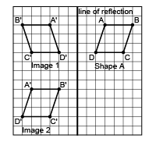  “I can picture Shape A’s reflection Image 1 on the other side of the line, with matching vertices the same distance from the line of reflection. I can picture moving Shape A left 8 squares and down 7 squares  to Image 2.”
Observations/Documentation

