Investigating Quadrilaterals
Recognizes and names different quadrilaterals.  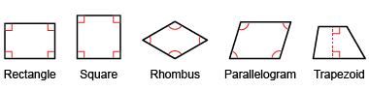  “These are all quadrilaterals because they have 4 sides. Each one has a special name.” | Identifies and describes attributes used to sort a set of quadrilaterals.  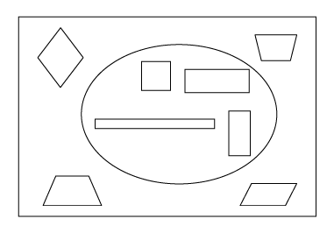  “All the quadrilaterals inside the loop have: opposite sides equal and parallel, 4 right angles, and at least 2 lines of symmetry.” | Sorts a given set of quadrilaterals and explains the sorting rule.  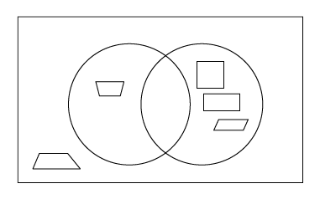  “In the left loop, I placed quadrilaterals with 1 pair of equal sides (an isosceles trapezoid). In the right loop, I placed quadrilaterals with opposite sides parallel (square, rectangle, parallelogram).” | Flexibly analyzes attributes of quadrilaterals to determine how they are alike.  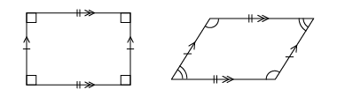  “A rectangle is a parallelogram because it has opposite sides equal and parallel, and opposite  angles equal.”
Observations/Documentation

