Interpreting Data and Making Informed Decisions
Draws conclusions based on data presented.  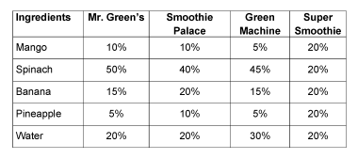  “Mr. Green’s has the most spinach and Super Smoothies has equal parts of each ingredient.” | Uses inferences to make predictions about future events.  “It seems that the Green Machine uses the most water. I predict that Green Machine smoothies won’t be very thick.” | Interprets the results of data presented graphically, using different types of graphs.  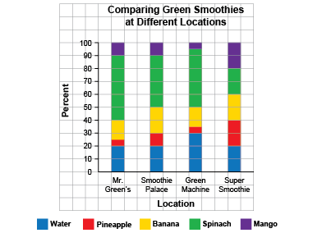  “I like the stacked bar graph best because I can compare the parts easily. I think Super Smoothie will have the sweetest smoothie because there’s lots of fruit.” | Analyzes and interprets data to make convincing arguments and informed decisions.  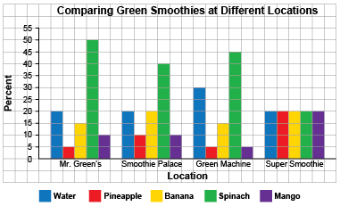  “In the future, I am going to buy a smoothie from Super Smoothies because it has the most fruit.”
Observations/Documentation

