Collecting, Organizing, and Representing Data
Formulates questions to make comparison between two groups or events.  What volunteer activity would your family most like to do: food bank, helping seniors, park cleanup, animal shelter?  “I would survey 10 students from both grade 5 classes, then compare results.” | Chooses the most efficient sampling technique to collect data that is a representative  of a population.  “I used systematic random sampling. I got a list of all families who volunteered and surveyed every fifth family on the list.” | Collects and displays data using  appropriate organizers.  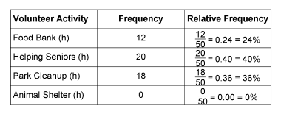  “I used a relative frequency table to record the data for each family.”
Observations/Documentation

Collecting, Organizing, and Representing Data (cont’d)
Represents and analyzes collected data.  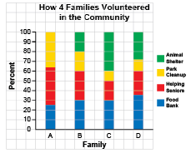  “I used a stacked bar graph because I can easily compare the heights of the different sections.” | Chooses appropriate visual representation to display data and justifies choice of graph.  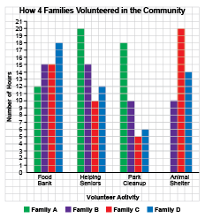  “I used a multiple bar graph because I can quickly make comparisons to make convincing arguments and informed decisions.” | Creates infographic to tell a story about the data.  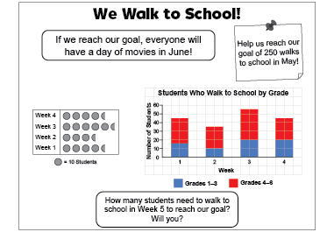  “The audience is students at the school. The message is that more students need  to walk to school.”
Observations/Documentation

