Collecting, Organizing, and Representing Data
Differentiates between first-hand and second-hand data.  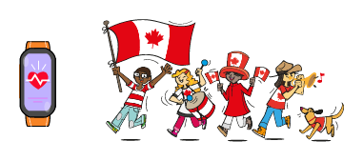  “First-hand data is when I survey the people on my street to see if they want a street party on Canada Day. Second-hand data is when my fitness tracker collects  the number of steps I take.” | Formulates questions to make comparisons between two groups or events.  Which type of music do you like to listen to the most: Country, Modern, Rock, Dance,  Sounds of Nature?  “I would ask two different grade 5 classes which type of music they prefer to listen to,  then make a comparison.” | Chooses the most efficient sampling technique to collect data that is representative of a population.  “I would collect first-hand data when finding out about classmates, friends, and family; people I can survey or talk to directly. It is better to collect second-hand data when finding out about Canada, Canadians, and large populations.”
Observations/Documentation

Collecting, Organizing, and Representing Data (cont’d)
Collects and displays two sets of data using appropriate organizers.  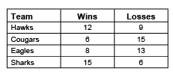  “I collected first-hand data from members of each of the 4 teams and displayed the data in a table.” | Represents two sets of data on a double-bar graph using many-to-one correspondences.  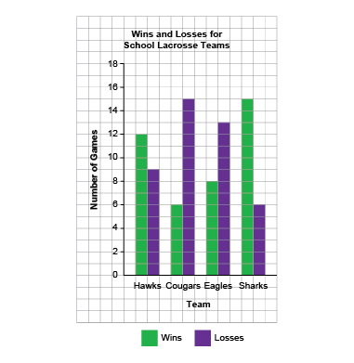  “I used a scale of 2:1 to display the 2 sets of data because most of the numbers were even numbers and an odd number would end with half a square.” | Creates double-bar graphs using first-hand and second-hand data using many-to-one correspondences.  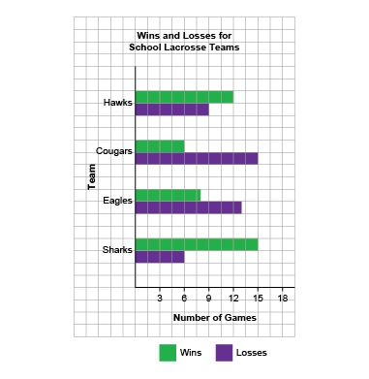  “I decided to display the data using a horizontal double-bar graph because it is easier to read. It has a 3:1 scale because most of the numbers were multiples of 3.”
Observations/Documentation

