Multiplying and Dividing Larger Numbers

Uses divisibility tests to identify numbers that are divisible by 2, 3, and 5.  285  “Not divisible by 2 as the ones digit is not even.  Divisible by 3 because the sum of the digits, 15, is divisible by 3.  Divisible by 5 as the ones digit is 5.”  (« Non divisible par 2 car le chiffre des unités n’est pas pair. Divisible par 3 car la somme des chiffres, 15, est divisible par 3. Divisible par 5 car le chiffre des unités est 5. ») | Models multiplication and division situations concretely and pictorially (i.e., using Base Ten Blocks, arrays, open arrays)  258 $×$ 15 = ?  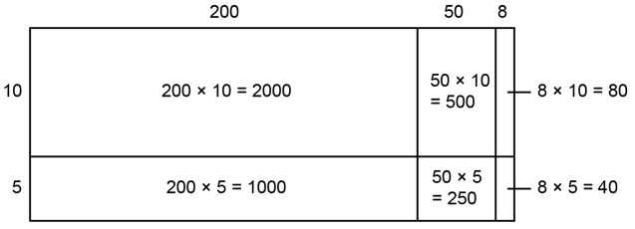  “I used an open array and added all the areas:  2000 + 1000 + 500 + 250 + 80 + 40 = 3870.  So, 258 $×$ 15 = 3870.”  (« J’ai utilisé une matrice ouverte et additionné toutes les sections. ») | Uses standard algorithms to multiply and divide  258 $×$ 15 = ?  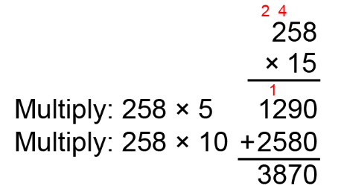  “I used the standard algorithm to multiply.”  (« J’ai utilisé l’algorithme usuel pour multiplier. »)
Observations/Documentation

Multiplying and Dividing Larger Numbers (cont’d)
Estimates to determine if answer to multiplication or division problem is reasonable  258 $×$ 15 = 3870  “258 is close to 250.  250 $×$ 15 = (250 $×$ 10) + (250 $×$ 5)  = 2500 + 1250  = 3750  3870 is close to 3750.  So, my answer is reasonable.”  (« 258 est proche de 250.  250 $×$ 15 = (250 $×$ 10) + (250 $×$ 5)  = 2 500 + 1 250  = 3 750  3 870 est proche de 3750.  Donc, ma réponse est vraisemblable. ») | Expresses a quotient with or without a remainder according to context  There are 114 students going on field trip.  Each bus holds 9 students.  How many buses are needed?  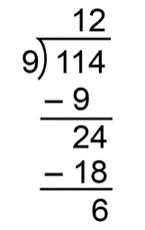  114 $÷$ 9 = 12 R6  “Since 6 students cannot be left behind,  13 buses are needed.”  (« Puisque 6 élèves ne peuvent pas être laissés derrière, il faut 13 autobus. ») | Creates and solves multiplication and division problems flexibly using a variety of strategies  5 elephants share 748 kg of food.  How much food does each elephant get?  748 ÷ 5 = (500 ÷ 5) + (200 ÷ 5) + (45 ÷ 5) + (3 ÷ 5)  = 100 + 40 + 9 + (3 ÷ 5)  = 149 R3, or 149$\frac{3}{5}$or 149$\frac{6}{10}$, or 149.6  Each elephant got 149.6 kg of food.  (« Chaque éléphant a obtenu 149,6 kg de nourriture. »)
Observations/Documentation

