Conceptual Meaning of Whole Number Addition and Subtraction
Recognizes addition and subtraction situations to 1 000 000  How many views did the video get on its first two days online?  “To find the total number of views, I need to add the number of views on Day 1 and the number of views on Day 2.”  (« Pour connaître le nombre total de vues, je dois additionner le nombre de vues du jour 1 et le nombre de vues du jour 2. ») | Models and symbolizes ways to solve problems to 1 000 000  156 231 + 275 489 = ?  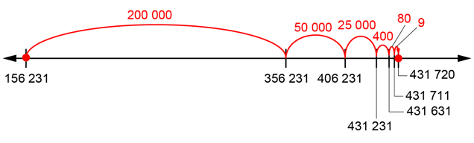 | Uses an understanding of place value to decompose numbers to solve problems to  1 000 000  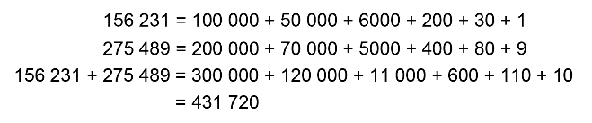  “I added hundred thousands with hundred thousands, ten thousands with ten thousands, thousands with thousands, and so on.  I added like units.”  (« J’ai additionné des centaines de milliers avec des centaines de milliers, des dizaines de milliers avec des dizaines de milliers, des milliers avec des milliers, et ainsi de suite. J’ai additionné des unités semblables. »)
Observations/Documentation

Conceptual Meaning of Whole Number Addition and Subtraction (cont’d)
Uses an understanding of place value to add and subtract to 1 000 000 using the standard algorithm  968 867 – 790 283 = ?  “I used the standard algorithm.”  (« J’ai utilisé l’algorithme usuel. ») | Estimates to determine if answer to problem is reasonable  968 867 – 790 283 = ?  “968 867 is close to 970 000 and 790 283 is close to 800 000.  970 000 – 800 000 = 170 000.  178 584 is close to 170 000.  So, my answer is reasonable.”  (« 968 867 est proche de 970 000 et 790 283 est proche de 800 000.  970 000 – 800 000 = 170 000.  178 584 est proche de 170 000.  Ma réponse est donc vraisemblable. ») | Creates and solves multi-step addition and subtraction problems flexibly using a variety of strategies  A dancing monkey video got 54 977 likes one day and 127 522 likes the next. How many more likes does it need to reach 250 000?  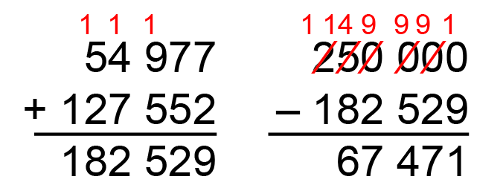
Observations/Documentation

