Locating and Plotting Points on a Coordinate Grid
Uses coordinates to describe the location of points on a grid  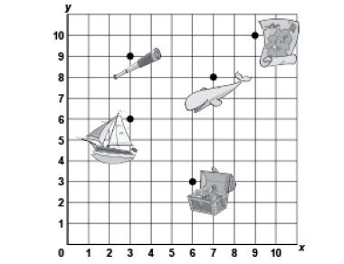  “The treasure chest is located at  (6, 3).”  (« Le coffre au trésor est situé à (6, 3). ») | Plots, locates, and labels points on a grid  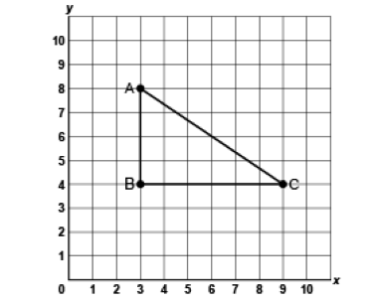  “I plotted A(3, 8), B(3, 4) and C(9, 4).  I joined the points to create a right triangle.”  (« J’ai tracé A(3, 8), B(3, 4) et C(9, 4). J’ai joint les points pour créer un triangle rectangle. ») | Uses positional language to describe the location of a point on a grid in relation to another point  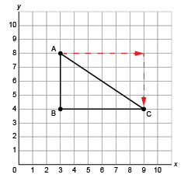  “Move right 6 squares and  down 4 squares from  Point A to get to Point C.”  (« Se déplacer de 6 cases à droite et de 4 cases en bas à partir du point A pour aller au point C. ») | Flexibly models and describes the location of the vertices of a polygon on a grid  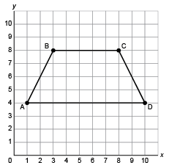  “The vertices of the trapezoid are at: A(1, 4), B(3, 8), C(8, 8), D(10, 4).”  (« Les sommets du trapèze se trouvent à : A(1, 4), B(3, 8), C(8, 8), D(10, 4). »)
Observations/Documentation

