Analyzing and Classifying 2-D Shapes and Using Algebraic Thinking
Reads and alters code by testing out various values or blocks until desired outcome is attained.  “I’m going to change the steps to 50 and the wait to 2 and the degrees to 90.” | Reads and alters code by visualizing and explaining the impact of changes until desired outcome is achieved.  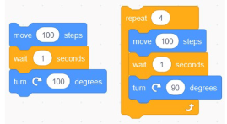  “I’ll change the steps to 50, the degrees to 90, and I’ll delete the wait because it doesn’t impact the end image, only how long it takes to make. And I can just repeat 4 times to get a square.” | Reads and flexibly alters code, including an ability to alter the same code in different ways for the same desired outcome.  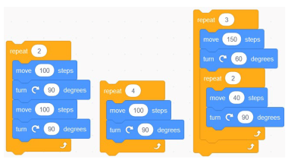  “I’m going to alter this to use fewer blocks. Since the actions are equal in both code sequences, the outcome will be the same.” Or “This nested loop is another way to create this design without so many blocks.”
Observations/Documentation

Analyzing and Classifying 2-D Shapes and Using Algebraic Thinking (cont’d)
Uses basic blocks to write code for a desired outcome  “I tried using these blocks in this order, but it didn’t make what I wanted.” | Uses more complex blocks (including repeat) to write code for a desired outcome  “I wrote code, but it used so many blocks. I can see that these blocks repeat. So, I used the repeat block instead and deleted these other blocks.” | Uses complex blocks to flexibly write different code for the same desired outcome  “Coding and algebra are very connected. Comparing the code sequences in these blocks is like comparing equivalent expressions. As long as the final outcome is the same, there are many code sequences that can create it.”
Observations/Documentation

Writing, Reading, and Altering Code on a Grid
Tests movements on a grid involving sequential events  “They took 3 steps forward, did a $\frac{1}{4}$ turn clockwise, then took 2 steps forward to get to the ball.” | Visualizes and predicts movements on a grid  involving sequential events  “I’m going to take 3 steps forward, do a $\frac{1}{4}$ turn clockwise, then take 2 more steps forward. If I did a $\frac{1}{4}$ turn clockwise first, then I would have to take 2 steps forward, do a $\frac{1}{4}$ turn counterclockwise, and then 3 steps forward. Both ways get me to the same location.” | Tests the movement of two different characters at the same time involving concurrent events  “The owner walked forward and the dog walked forward. But they ran into each other. Oops.”
Observations/Documentation

Writing, Reading, and Altering Code on a Grid (cont’d)
Flexibly writes, reads and alters code involving concurrent events  “If the dog runs forward, then the owner has to turn at this point, or they’ll run into each other. The dog could take a $\frac{1}{4}$ turn clockwise back here and that will solve that problem. Now I just need the owner to have more wait time.” | Tests the repeated movements on a grid involving repeating events  “I wrote this code but when my partner acted it out, it didn’t work as I thought it would. I think this part of the code repeats, but my partner says that the way I wrote it, this whole part repeats.” | Visualizes the repeating nature of the movements on a grid involving repeating events  “I decided to use the repeat after the first step in the code. This way I wouldn’t have to change the direction of the dog after it got to the doghouse and the dog could just move forward.”
Observations/Documentation

