Solving Unknowns in Equations
Uses concrete materials to “guess and check.”  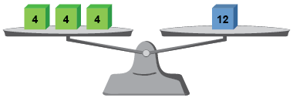  “I know that 3 multiplied by 4 is 12.” | Draws and interprets pictures using a balance model.  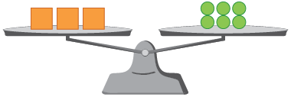  $$3 ×∎=6$$  “I placed 1 in each group until the pans balanced; ◼ = 2” | Decomposes and recomposes numbers.  3 × 8 =$∎$  $$3×8=\left(2×8\right)+\left(1×8\right)$$  $$\left(2×8\right)+\left(1×8\right)=16+8$$  $$16+8=24$$  “I can decompose the equation into parts that can help me solve for the unknown.”
Observations/Documentation
 |  | .

Solving Unknowns in Equations (cont’d)
Uses relationships and properties of operations (inverse operations, associative property).  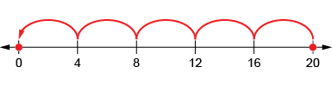  $$20=4×∎$$  “I rewrote the equation as a division equation: $20÷4=∎.$” | Writes a statement for a given equation and solves for the unknown.  $$∎÷6=3$$  “I had a bag of baby carrots. I shared them equally with me and 5 friends and we each ended up with 3. How many baby carrots were in the bag to start?” | Flexibly uses multiple strategies to solve equations.  ◼ × 2 = 30 – 4  “I know something times 2 is equal to 26, because 30 − 4 is 26.  I can rewrite using division: 26 ÷ 2 = $∎.$ So, the unknown is 13.”
Observations/Documentation

