Generalizing and Representing Patterns
Recognizes that a pattern can repeat, increase, or decrease.  “This is an increasing pattern. I know this because each time there are more blocks.” | Identifies how a pattern changes and describes the pattern rule.  “The pattern rule is: Start with 1 hexagon and 6 triangles. Add one hexagon and 6 triangles each time.” | Represents patterns using a table  or chart.  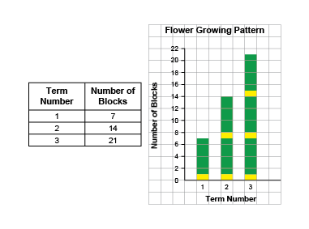  “The table shows the number of blocks increases by 7 each time, and the graph shows the height of the bars increases by  the same amount.”  Term Number Number of Blocks  1 8  2 16  3 24 | Represents patterns symbolically and writes the pattern rule.  7, 14, 21  “The number of blocks in each term increases by 7 because  each flower has 7 blocks.  Term 3: 7 + 7 + 7 = 21.”
Observations/Documentation

Sorting in Venn and Carroll Diagrams
Identifies and describes a sorting rule for numbers shown in a Venn diagram.  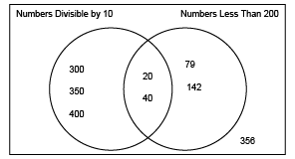  “The numbers in the left loop are divisible by 10 and the numbers in the right loop are less than 200. The numbers 20 and 40 are in the intersection of the loops because they fit both sorting rules.” | Creates a Venn diagram to represent and describe number pattern relationships.  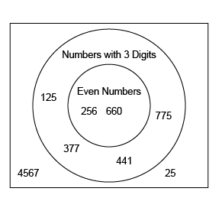  “I created this Venn diagram to represent the pattern relationships. The outer circle has 3-digit numbers and the inner circle has 3-digit numbers that are even. The outer numbers are not 3-digit numbers.” | Completes a Carroll diagram to solve a problem about number pattern relationships.  Where would you put 135, 304, 14, 512, 21, 28 in the Carroll diagram?  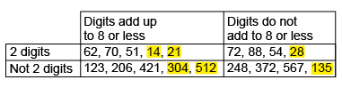 | Fluently and flexibly identifies, describes, and solves a problem using charts or diagrams.  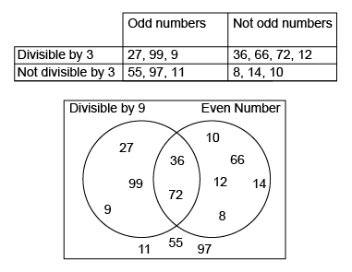  ”I used the same numbers but sorted them differently to identify and describe different pattern relationships.”
Observations/Documentation

