Fluency of Multiplication and Division Facts
Recalls and demonstrates multiplication and divisions facts  to 5 × 5.  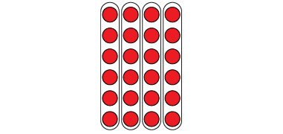  “I know that 4 × 6 = 24  and that 24 ÷ 6 = 4.  The array shows both facts.” | Uses inverse operations to solve multiplication and division problems.  “I can rewrite 24 ÷ 6 = ?  as 6 × ? = 24.” | Uses known facts to determine unknown facts  “I can use the distributive property to split the multiplication into facts that I know, then add.”  5 × 9 = 5 × 5 + 5 × 4  25 + 20 = 45  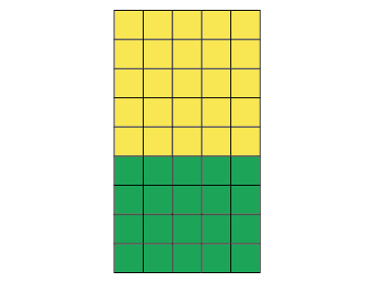 | Fluently creates and solves whole number multiplication and division problems.  There are 56 basketballs with the same number on each of 8 shelves.  8 × □ = 56, so 56 ÷ 8 = □  8 × 7 = 56  Or  8 × 7 = 4 × 7 + 4 × 7  = 28 + 28  = 56  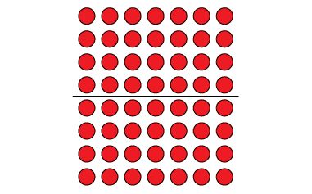
Observations/Documentation

