Exploring Fractions
Partitions whole (area or length) into equal parts  “I folded the line into 4 equal parts.” | Counts parts using unit fractions  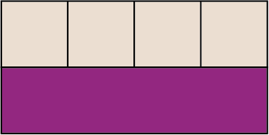  “1 one-fourth, 2 one-fourths,  3 one-fourths, 4 one-fourths” | Understands the meaning of the numerator and denominator  “I counted 4 one-fifths, which tells me I have $\frac{4}{5}$ altogether.  4 is the number of parts shaded and 5 is the total number of equal parts.” | Compares unit fractions  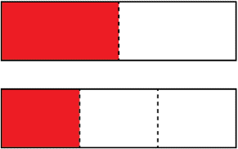  “One-half is bigger than one-third  of the same whole.”
Observations/Documentation

Exploring Fractions (cont’d)
Understands relationship between number of parts (denominator) and the size of the parts  “When I divide the same whole into 8 equal parts or 10 equal parts, there are more tenths and each tenth is smaller than each eighth.” | Moves comfortably across different representations of fractions  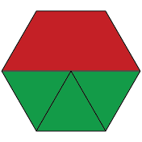  “As a set, the trapezoid represents $\frac{1}{4}$ (1 of 4 items). As an area model,  the trapezoid represents $\frac{1}{2}$.” | Understands that, for the same whole, equivalent fractions represent the same quantity  ”$\frac{2}{3}$ and $\frac{4}{6}$ represent the same amount, but $\frac{4}{6}$ has  twice as many parts as $\frac{2}{3}$.” | Uses fraction sense (e.g., benchmarks) to compare and order fractions  “I know $\frac{4}{6}$ is a little more than half, $\frac{8}{9}$ is pretty close to one whole,  and $\frac{1}{5}$ is close to zero.”
Observations/Documentation

