Conceptual Meaning of Whole Number Addition and Subtraction
Recognizes addition and subtraction situations and models concretely to add or subtract to 1000  148 + 223 = ?  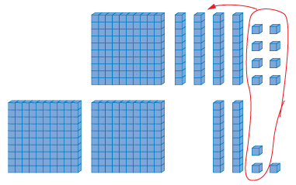 | Models and symbolizes ways to solve problems to 1000  148 + 223 = ?  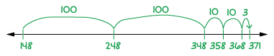 | Uses an understanding of place value to decompose both numbers to solve problems to  10 000  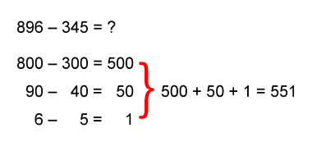  “I subtracted the hundreds, the tens,  and then the ones.”
Observations/Documentation

Conceptual Meaning of Whole Number Addition and Subtraction (cont’d)
Uses an understanding of place value to decompose one number to solve problems  to 10 000  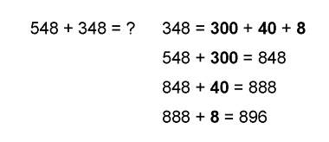  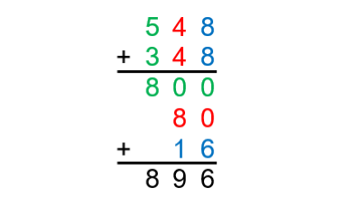  “I used place value to  add on the second number.” | Estimates to determine if answer to problem is reasonable  896 - 345 = ?  “896 is close to 900. 345 is close to 350.  900 - 350 = 550. 550 is close to 551, the answer I calculated, so my answer is reasonable.” | Creates and solves addition and subtraction problems flexibly using a variety of strategies  1874 raffle tickets were sold in advance. 227 more tickets were sold at the door. How many tickets were sold altogether?
Observations/Documentation

