Representing Numbers Using Place Value
Models number using Base Ten Blocks (decomposes in one way)  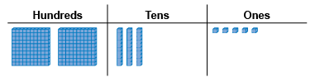  “I modelled 235. I used the digits of the number to tell me how many of each block I needed.” | Models 3-digit number (decomposes in more than one way) and records using place-value names  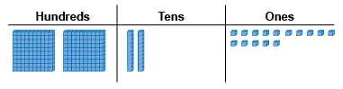  “two hundred thirty-five:  I can also show it as 2 hundreds,  2 tens and 15 ones if I trade 1 ten for 10 ones.” | Models 4-digit number using Base Ten Blocks (decomposes in one way)  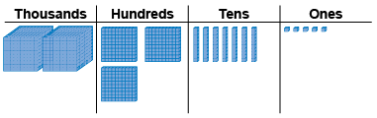  “I modelled 2375. I used the digits of the number to tell me how many of each block I needed.”
Observations/Documentation

Representing Numbers Using Place Value (cont’d)
Systematically models 4-digit number in more than one way using patterns and place-value relationships  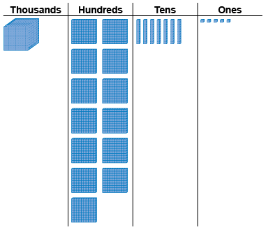  “I traded one thousand cube  for 10 hundred flats.” | Models 4-digit number in more than one way and records each way in expanded form  “2375 = 1000 + 1300 + 70 + 5” | Represents numbers flexibly using place-value relationships  “2375 = 2000 + 300 + 70 + 5  2375 = 2000 + 300 + 60 + 15  2375 = 2000 + 300 + 50 + 25  2 thousands, 3 hundreds, 4 tens, 35 ones
Observations/Documentation

