Using Measurement of Time
Tells time using fractions.  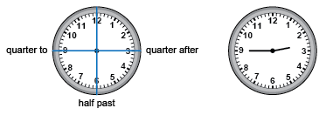  “It is quarter to three or two forty-five.” | Tells time using one- and five-minute intervals on analogue and digital clocks.  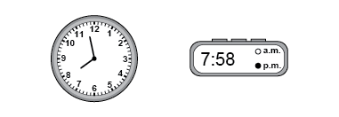  “Both the analogue and digital clocks read: Seven fifty-eight, or 2 minutes before 8. In 2 minutes, the clocks will read 8:00.” | Tells time using 24-hour clocks.  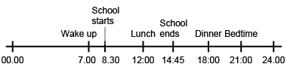  “I created a timeline to record the times of my daily activities using a 24-hour clock. I converted 12-hour p.m. times to 24-hour times.”
Observations/Documentation

Using Measurement of Time (cont’d)
Solves problems using elapsed time and the relationships among units of time.  Buses leave at 14:15, 14:26, 14:47, and 14:58.  Each trip back takes 1 hour and 11 minutes.  Dara needs to be back by 3:45 p.m.  Which buses can Dara take?  “I converted 3:45 p.m. to 24-hour time by adding 12 hours: 15:45. I added 1 hour and 11 minutes to each departure time to get the arrival time: 15:26, 15:37, 15:58, 16:09. Two of the buses arrive before 15:45. So, Dara can take the 14:15 or 14:26 bus.” | Reads and records calendar dates in different formats.  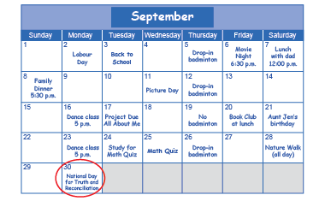  “The National Day for Truth and Reconciliation  is on September 30, 2024.  That date could also be recorded as:  09/30/2024, 2024/09/30, or 30/09/2024.” | Flexibly solves problems involving time using various strategies and the relationships among units.  Over a week, Axel got 56 h of sleep, Sadie got 3000 min of sleep, and Piper got 2$\frac{1}{2}$ days of sleep. Who got the most sleep?  “I converted all the times to hours. Sadie: 60 min = 1 h, and 3000 min ÷ 60 min = 50.  So, 3000 min = 50 h.  Piper: 1 day = 24 h, 2 days = 48 h, and one-half of a day is 24 h ÷ 2 = 12 h.  So, 2$\frac{1}{2}$ days = 48 h + 12 h = 60 h.  60 h > 56 h > 50 h.  Piper got the most sleep.”
Observations/Documentation

