Investigating Mass
Identifies which metric unit should be used to measure the mass of an object.  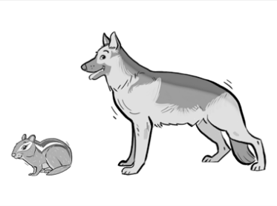  “I would use grams to measure the mass of the chipmunk and kilograms to measure the mass of the German Shephard.” | Uses benchmarks to estimate mass using metric units.  “A paperclip is about 1 g. I estimated that a pencil is about 6 grams.  When I used a balance scale, it took about 6 paper clips to balance the pencil.” | Chooses an appropriate metric unit to estimate and measure mass of objects and explains reasoning.  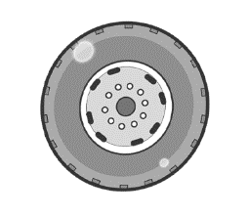  “I would use kilograms to measure the mass of the tire because I know that a tire would weigh about the same as a 10 kg bag of potatoes.”
Observations/Documentation

Investigating Mass (cont’d)
Explains the relationship between grams and kilograms and converts between units of measure.  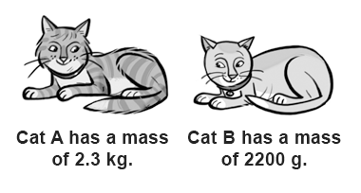  “I know 1000 g = 1 kg and 2.3 kg = 1000 g × 2.3, or 2300 g. Since 2300 g > 2200 g, Cat A has the greater mass.” | Compares and orders objects with masses given in different units.  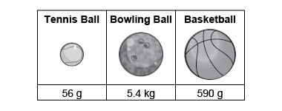  “I converted the mass of the bowling ball  to grams: 1 kg = 1000 g and  5.4 kg = 5.4 × 1000 g = 5400 g.  The order from least to greatest mass is tennis ball, basketball, bowling ball.” | Flexibly solves problems in various contexts where measures of mass are given in different units.  There are 6 apples in a bag.  The mass of the bag of apples is 1 kg.  About how much is the mass of 1 apple?  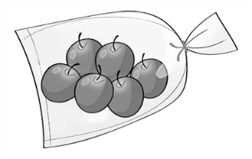  “The bag of apples is 1000 g; 6 × 150 = 900 and  6 × 15 = 90, which totals about 1000.  The mass of each apple  is about 150 g + 15 g = 165 g.”
Observations/Documentation

Investigating Capacity
Identifies which metric unit should be used to measure the capacity of an object.  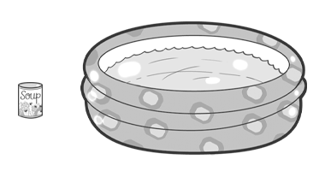  “I would use millilitres to measure the capacity of the can of soup and litres to measure the capacity of the swimming pool.” | Uses benchmarks to estimate capacity using metric units.  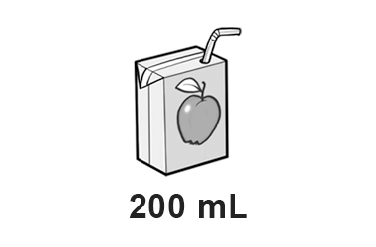  “I would estimate that it would take about 5 juice boxes to fill the jug, so the jug has a capacity of about 1 L because 5 × 200 mL = 1000 mL = 1 L.” | Chooses an appropriate metric unit to estimate and measure capacity of objects and explains reasoning.  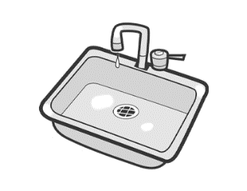  “I would use litres to measure the capacity of the sink because I know that the sink has a capacity much greater than that of a 1-L carton of milk.”
Observations/Documentation

Investigating Capacity (cont’d)
Explains the relationship between millilitres and litres and converts between units of measure.  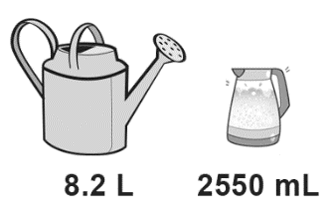  “I know 1000 mL = 1 L and 8.2 L = 1000 mL × 8.2, or 8200 mL. Since 8200 mL > 2550 mL, the watering can has the greater capacity.” | Compares and orders objects with capacities given in different units.  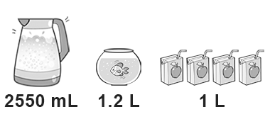  “I converted the capacity of the kettle to litres: 1 L = 1000 mL and 2550 mL = 2550 ÷ 1000 = 2.55 L.  The order from least to greatest capacity is juice boxes, fishbowl, kettle.” | Flexibly solves problems in various contexts where measures of capacity are given in different units.  How many 250 mL cups of water  will it take to fill a 2.75 L jug?  “I know 4 × 250 mL = 1000 mL; 8 × 250 mL = 2000 mL, and 250 mL × 3 = 750 mL; 2000 mL + 750 mL = 2750 mL; 8 + 3 = 11; It would take eleven 250 mL cups to fill the 2.75- L jug.”
Observations/Documentation

