Investigating Mass
Identifies which metric unit should be used to measure the mass of an object.  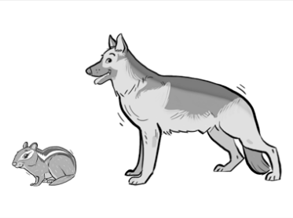  “I would use grams to measure the mass of the chipmunk and kilograms to measure the mass of the German Shephard.” | Uses benchmarks to estimate mass using metric units.  “A paperclip is about 1 g. I estimated that a pencil is about 6 grams.  When I used a balance scale, it took about 6 paper clips to balance the pencil.” | Chooses an appropriate metric unit to estimate and measure mass of objects and explains reasoning.  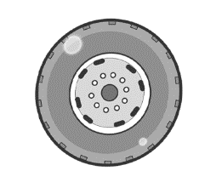  “I would use kilograms to measure the mass of the tire because I know that a tire would weigh about the same as a 10 kg bag of potatoes.”
Observations/Documentation

Investigating Mass (cont’d)
Explains the relationship between grams and kilograms and converts between units of measure.  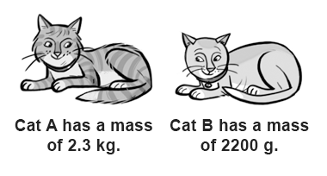  “I know 1000 g = 1 kg and 2.3 kg = 1000 g × 2.3, or 2300 g. Since 2300 g > 2200 g, Cat A has the greater mass.” | Compares and orders objects with masses given in different units.  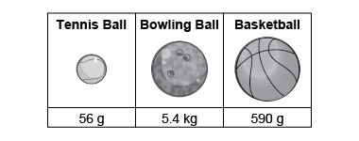  “I converted the mass of the bowling ball  to grams: 1 kg = 1000 g and  5.4 kg = 5.4 × 1000 g = 5400 g.  The order from least to greatest mass is tennis ball, basketball, bowling ball.” | Flexibly solves problems in various contexts where measures of mass are given in different units.  There are 6 apples in a bag.  The mass of the bag of apples is 1 kg.  About how much is the mass of 1 apple?  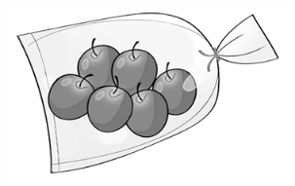  “The bag of apples is 1000 g; 6 × 150 = 900 and  6 × 15 = 90, which totals about 1000.  The mass of each apple  is about 150 g + 15 g = 165 g.”
Observations/Documentation

