Investigating Perimeter
Uses standard units to measure the perimeter of irregular polygons by adding the lengths of its sides  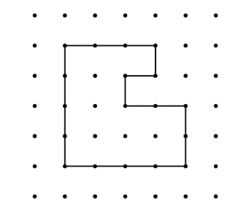  ”The polygon is on 1-cm dot paper. I added the lengths of the sides: 3 cm + 4 cm + 4 cm + 2 cm + 2 cm + 1 cm + 1 cm + 1 cm = 18 cm;  The perimeter of the shape is 18 cm.” | Uses standard units to calculate the perimeter of regular polygons.  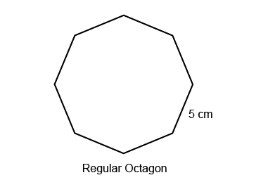  “In a regular octagon, all sides are the same length. To find the perimeter, I multiply the length of one side by the number of sides: 5 cm × 8= 40 cm. The perimeter is 40 cm.” | Constructs different polygons for a given perimeter.  Perimeter = 12 cm  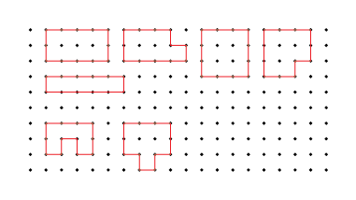  “I created these irregular and regular polygons, each with perimeter 12 cm. With irregular polygons, I added all the side lengths to check. The square is a regular polygon, so I multiplied the length of one side by 4.”
Observations/Documentation

Investigating Perimeter (cont’d)
Chooses an appropriate metric unit to estimate and measure perimeter of objects and explains reasoning.  “I used metres to measure the perimeter of the carpet because the carpet is longer and wider than the width of a door.  Length: 3 m, Width: 2.5 m.  Perimeter: 3 m + 2.5 m + 3 m + 2.5 m = 11 m.” | Understands the relationships among standard units of length and justifies when an exact measure of perimeter is needed.  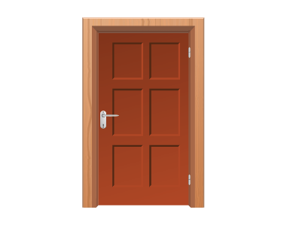  How much trim is needed to go around the door?  “An exact measure is needed so that the trim fits without gaps or overlaps.  I would use metres and centimetres.  Height: 2 m 54 cm,  Width: 1 m 6 cm  Perimeter: 2 m 54 cm + 2 m 54 cm + 1 m 6 cm + 1 m 6 cm = 6 m 120 cm, or 7 m 20 cm.” | Fluently solves problems in various contexts involving the perimeter of irregular and regular polygons.  Rashad wants to build a fence to make a rectangular pen for the rabbits using 24 m of fencing, in 1-m lengths. Which dimensions would you choose for the pen?  “The sum of a length and a width is  one-half of 24 m, or 12 m.  The possible dimensions are: 1 m by 11 m;  2 m by 10 m; 3 m by 9 cm; 4 m and 8 m;  5 m by 7 m; 6 m by 6 m.  I would choose 6 m by 6 m to make a square pen that would fit in my backyard.”
Observations/Documentation

Estimating and Investigating Area
Recognizes that area is measured using square units.  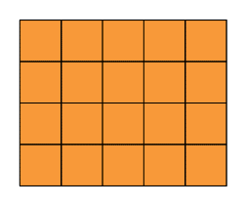  ”I covered the rectangle with square tiles and determined the area to be 20 square units.” | Uses referents to estimate area of regular and irregular shapes, then measures to check.  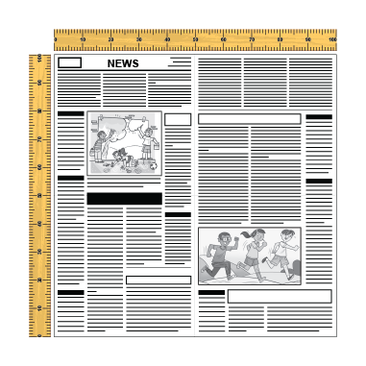  “I chose a square piece of newspaper as a referent for 1 m². I used the referent to estimate and measure the area of the blackboard. I estimated the area to be 25 m²  and it was actually 32 m².” | Determines area by counting squares, using square metres and/or square centimetres.  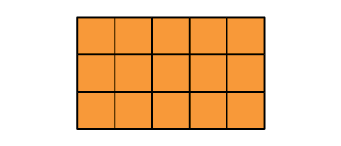  “On the grid, each square represents 1 square centimetre. There are 15 squares, so the area of the rectangle is 15 cm².” | Determines the area of regular shapes by counting whole and half squares.  “I counted squares on the 1-cm grid: 12 whole squares and 4 half squares, which make 2 whole squares, so the area is 14 cm.”
Observations/Documentation

Estimating and Investigating Area (cont’d)
Uses row and column structure of an array to determine area of a rectangle.  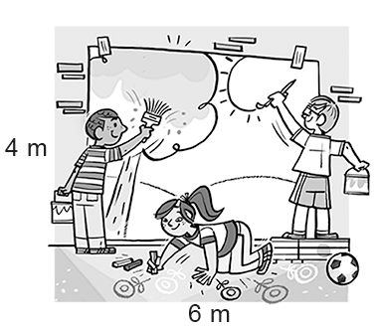  “I traced the shape on a grid and let each square represent 1 m². The rectangle forms an array with 4 rows of 6 squares: 4 × 6 = 24; the area of the mural is 24 m².” | Constructs different rectangles for a given area (square centimetres or square metres).  Area of rectangle = 16 cm²  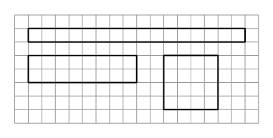  “I constructed 3 different rectangles: A square with side length 4 cm:  4 cm × 4 cm = 16 cm².  A 2-cm by 8-cm rectangle:  2 cm × 8 cm = 16 cm²  A 1-cm by 16- cm rectangle:  1 cm × 16 cm = 16 cm²” | Determines the area of irregular shapes by decomposing into known shapes.  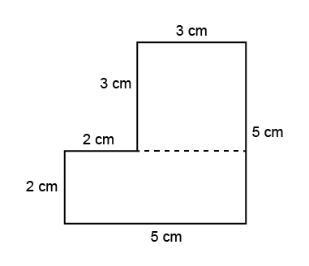  “I decomposed the shape into a square with side length 3 cm  and a rectangle with  length 5 cm and width 2 cm.  Area square:  A = 3 cm × 3 cm = 9 cm²  Area rectangle:  A = 5 cm × 2 cm = 10 cm²  Area of shape:  A = 9 cm² + 10 cm² = 19 cm²” | Flexibly determines the area of regular and irregular shapes and solves problems.  A driveway is made from 1 m2 tiles. It is a rectangle with area 75 m2. The driveway is 5 m wide. How long is it?  “I know A = l × w, so I solved the equation 75 = l × 5. I know 15 × 5 = 75, so the driveway is 15 m long.”
Observations/Documentation

