Investigating Length
Identifies which metric unit should be used to measure the length of an object.  “I would measure the length I walk everyday using kilometres and the length of a pencil using centimetres.” | Uses benchmarks to estimate length using metric units, then measures to check. 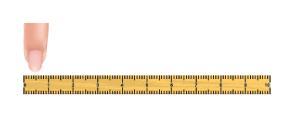  1 cm  “A finger width is about 1 cm.  I estimated that a new pencil is about 18 cm long.  The pencil measured 19 cm.” | Chooses an appropriate metric unit to estimate and measure the length of objects and explains reasoning.  “I would use metres to measure the height of the door because I know the height of the door is longer than its width, which is about 1 metre.”
Observations/Documentation

Investigating Length (cont’d)
Explains the relationships among millimetres, centimetres, metres, and kilometres and converts between units.  “I know that 1 dm = 10 cm. So, if my arm is 6 dm long, then I know that my arm is also 60 cm and 0.6 m long.” | Compares and orders objects by length when measures are given in different units.  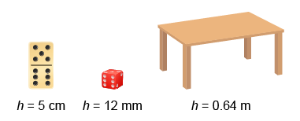  “I converted the height of each object to centimetres: 12 ÷ 10 = 1.2 and 0.64 × 100 = 64. The order from tallest to shortest is: number cube (1.2 cm), domino (5 cm), table (64 cm).” | Flexibly solves problems in various contexts where measures of length are given in different units.  A person must be at least 137 cm tall to go on a ride. Jamal is 1.4 m tall. Would Jamal be allowed on the ride?  “I know there are 100 cm in 1 m, so 1.4 m = 100 cm + 40 cm, or 140 cm. Since 140 cm > 137 cm, Jamal can go on the ride.”
Observations/Documentation

