Exploring 2-D Shapes by Applying and Visualizing Translations
Performs reflections using labelled vertices over various lines of reflection.  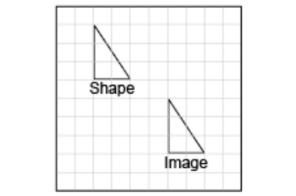  “This shows a translation because the two shapes are the same size and face the same way.” | Recognizes that a shape can be translated by moving it horizontally and vertically.  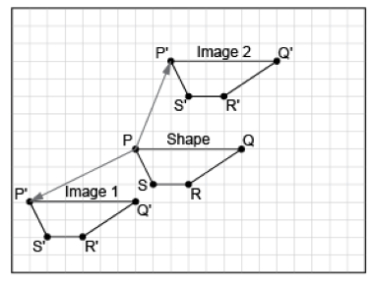  “I moved the shape to different places by moving it  left or right and up or down.” | Describes translations by counting grid squares and using directional language.  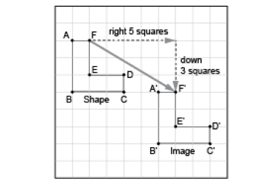  “I moved the shape right 5 squares and down 3 squares.” | Visualizes and predicts where the image of a shape will be after a translation.  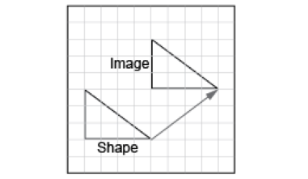  “I can picture moving the triangle right 4 squares and up 3 squares to its image.”
Observations/Documentation

