Exploring Congruence with 2-D Shapes
Identifies congruent 2-D shapes concretely and pictorially.  “These shapes are congruent because when I place them on top of each other, they are the same size and shape.” | Determines congruent 2-D shapes using visualization strategies.  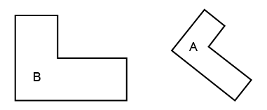  “These shapes are not congruent because I can see that one shape is larger than the other.” | Flexibly identifies congruent 2-D shapes in a collection with different orientations.  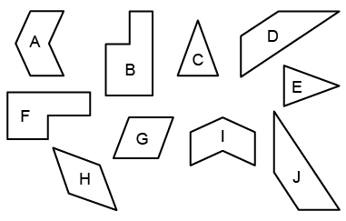  “I used a ruler and tracing paper to identify congruent shapes. I know matching sides and angles have the same measure.” | Creates a shape that is congruent to a given 2-D shape.  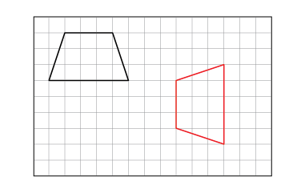  “I used the grid and a ruler to create a congruent shape in a different orientation.”
Observations/Documentation

