Collecting, Organizing, and Representing Data
Creates questions of interest that generate qualitative and/or quantitative data.  What types of waste do you have after eating your lunch: waste, recycling, organic?  “I will get qualitative data because the possible answers are categories.” | Collects data using appropriate organizers (e.g., frequency tables, stem-and-leaf plots).  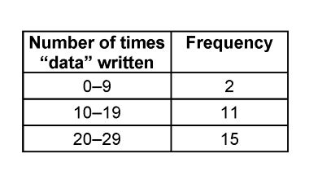  “I organized the data using a frequency table to I can see the number of times most students wrote the word data” | Represents results using various tools.  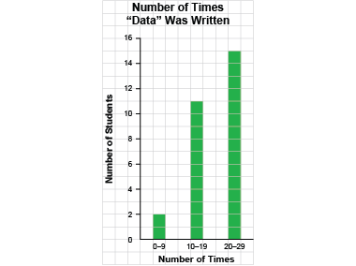  “I showed the data on a bar graph using many-to-one correspondence.”
Observations/Documentation

Collecting, Organizing, and Representing Data (cont’d)
Differentiates between primary and secondary data.  “When I collect information, it is primary data. When I use data collected by someone else, it is secondary data.” | Represents data graphically using many-to-one correspondence with appropriate scales and intervals.  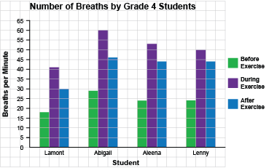  “I showed the data on a multiple-bar graph using many-to-one correspondence.” | Creates infographics to show data in appropriate ways and incorporates relevant information for a specific audience.  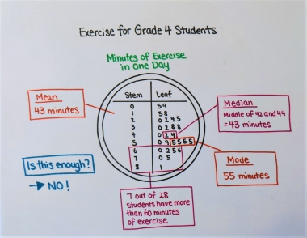  “I want Grade 4 students to use the data to decide if they get enough exercise.”
Observations/Documentation

Determining the Mean, Median, and Mode
Reads and interprets data displays to determine mode and mean.  Number of siblings for a group of Grade 4 students: 0, 1, 1, 3, 3, 4  • the mode: 1 and 3  • the mean is 2  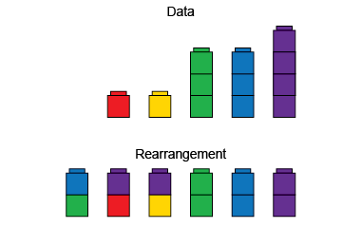 | Visualizes and determines the median value as a middle measure.  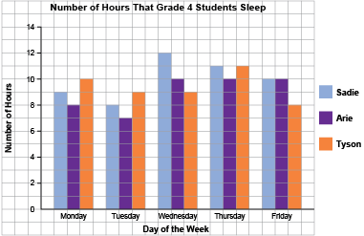  “For Sadie, I order the number of hours from least to greatest: 8, 9, 10, 11, 12. The middle number is 10, so the median is 10 h.” | Compares distribution of data sets represented on the same data display.  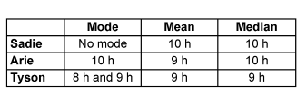 | Fluently and flexibly finds the mode, mean, and median and explains what each indicates.  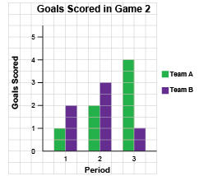  “Team B: no mode;  mean: 2 goals;  median: 2 goals.  Team B, on average,  scores 2 goals in each period.”
Observations/Documentation

