Interpreting Data and Making Informed Decisions
Draws conclusions based on data presented.  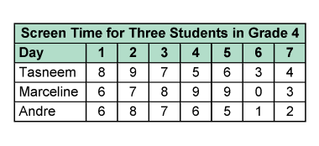  “The maximum recommended screen time is 5 h. All three students usually exceed that time.” | Uses inferences to make predictions about future events.  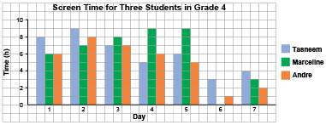  “On the weekend, the screen time is less. The students might be busy with other activities. Maybe they should find other activities to do during the week.” | Interprets data from primary and secondary resources presented graphically.  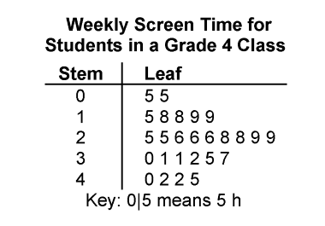  “I can use the stem-and-leaf plot to determine the mode, mean, and median, then make inferences based on the data.” | Uses data to draw conclusions and make convincing arguments/informed decisions.  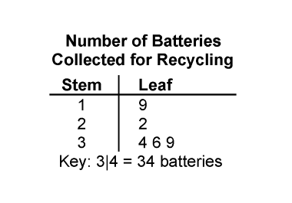  “The greatest number collected is 39. the least number is 19, and the median is 34. All the batteries will be recycled and will help stop electronic waste from going to landfill sites.”
Observations/Documentation

