Determining the Mean, Median, and Mode
Reads and interprets data displays to determine mode and mean.  Number of siblings for a group of Grade 4 students: 0, 1, 1, 3, 3, 4  • the mode: 1 and 3  • the mean is 2  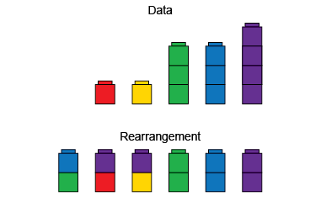 | Visualizes and determines the median value as a middle measure.  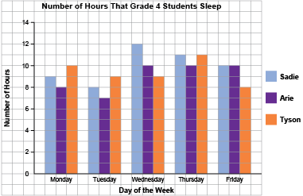  “For Sadie, I order the number of hours from least to greatest: 8, 9, 10, 11, 12. The middle number is 10, so the median is 10 h.” | Compares distribution of data sets represented on the same data display.  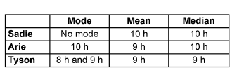 | Fluently and flexibly finds the mode, mean, and median and explains what each indicates.  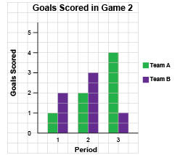  “Team B: no mode;  mean: 2 goals;  median: 2 goals.  Team B, on average,  scores 2 goals in each period.”
Observations/Documentation

