Collecting, Organizing, and Representing Data
Creates questions of interest that generate qualitative and/or quantitative data.  What types of waste do you have after eating your lunch: waste, recycling, organic?  “I will get qualitative data because the possible answers are categories.” | Collects data using appropriate organizers (e.g., frequency tables, stem-and-leaf plots).  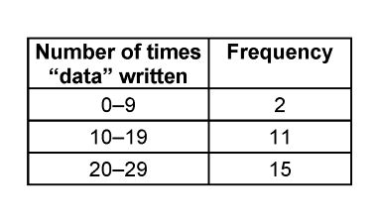  “I organized the data using a frequency table to I can see the number of times most students wrote the word data” | Represents results using various tools.  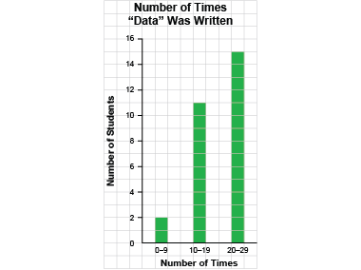  “I showed the data on a bar graph using many-to-one correspondence.”
Observations/Documentation

Collecting, Organizing, and Representing Data (cont’d)
Differentiates between primary and secondary data.  “When I collect information, it is primary data. When I use data collected by someone else, it is secondary data.” | Represents data graphically using many-to-one correspondence with appropriate scales and intervals.  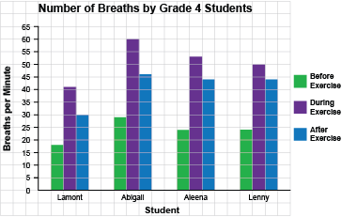  “I showed the data on a multiple-bar graph using many-to-one correspondence.” | Creates infographics to show data in appropriate ways and incorporates relevant information for a specific audience.  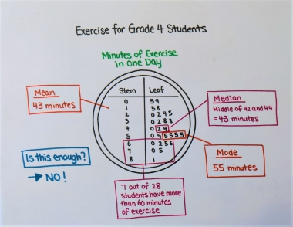  “I want Grade 4 students to use the data to decide if they get enough exercise.”
Observations/Documentation

