Investigating Increasing and Decreasing Sequences
Recognizes increasing and decreasing sequences in multiple representations.  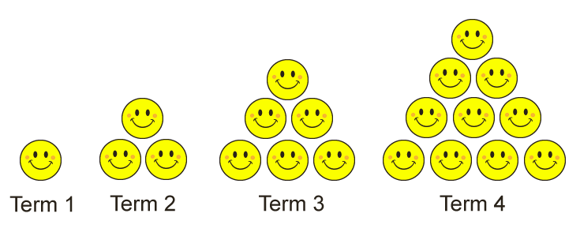  “That is an increasing sequence because the number of happy faces increases with each term.”  (« Il s’agit d’une suite croissante, car le nombre de visages souriants augmente à chaque terme. ») | Creates and explains increasing and decreasing sequences, including numerical sequences.  “The happy faces form equilateral triangles. We start with 1 happy face, add 2 happy faces, then increase the number added by 1 each time.”  (« Les visages souriants forment des triangles équilatéraux. Nous commençons par un visage souriant, nous ajoutons deux visages souriants, puis nous augmentons le nombre de visages souriants ajoutés de 1 à chaque fois. ») | Expresses a concrete or pictorial sequence as a number sequence.  “The number sequence is:  1, 3, 6, 10, …”  (« La suite arithmétique est :  1, 3, 6, 10, …. ») | Recognizes and describes increasing and decreasing arithmetic sequences.  1, 3, 5, 7, …  “This is an increasing arithmetic sequence as 2 is added each time.  Initial term: 1.  Constant change: Add 2.”  (« Il s’agit d’une suite arithmétique croissante puisque 2 est ajouté à chaque fois.  Terme initial : 1.  Changement constant : Ajouter 2. »)
Observations/Documentation

Investigating Increasing and Decreasing Sequences (cont’d)
Writes the first 5 terms of an arithmetic sequence given the initial term and constant change.  “Initial term: 30.  Constant change: Subtract 3.  30, 27, 24, 21, 18, …”  (« Terme initial : 30.  Changement constant : Soustraire 3.  30, 27, 24, 21, 18, … ») | Recognizes and describes increasing and decreasing geometric sequences.  2, 4, 8, 16, 32, …  “This is an increasing geometric sequence as a term is multiplied by 2 to get the next term.  Initial term: 2.  Constant change: Multiply by 2.”  (« Il s’agit d’une suite géométrique croissante car un terme est multiplié par 2 pour obtenir le terme suivant.  Terme initial : 2.  Changement constant :  Multiplier par 2. ») | Writes the first 5 terms of a geometric sequence given the initial term and constant change.  “Initial term: 2.  Constant change: Multiply by 3.  2, 6, 18, 54, 162, …”  (« Terme initial : 2.  Changement constant :  Multiplier par 3.  2, 6, 18, 54, 162, .... ») | Fluently recognizes and describes different increasing and decreasing sequences and uses them to solve problems.  It takes Sami 40 min to make  1 bracelet.  How many bracelets can Sami make in 4 h?  “This is an increasing arithmetic sequence. Initial term: 40.  Constant change: + 40.  40, 80, 120, 160, 200, 240  4 h = 240 min  Sami can make 6 bracelets. “  (« Il s’agit d’une suite arithmétique croissante. Terme initial : 40. Changement constant : + 40. Sami peut fabriquer 60 bracelets. »)
Observations/Documentation

