Conceptual Meaning of Addition and Subtraction of Decimals
Recognizes addition and subtraction situations and models concretely or pictorially to add or subtract to tenths  1.5 – 0.7 = ?  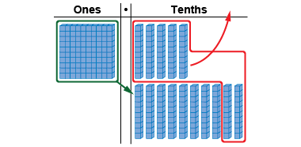  “15 tenths – 7 tenths = 8 tenths”  (« 15 dixièmes – 7 dixièmes = 8 dixièmes. »)  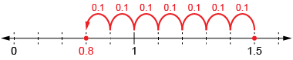  1.5 – 0.7 = 0.8 | Uses an understanding of place value to add or subtract decimals with tenths (using standard algorithm)  14.6 + 27.8 = ?  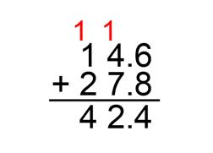  “I used the standard algorithm, adding the tenths, then the whole numbers.”  (« J’ai utilisé l’algorithme usuel, en additionnant les dixièmes, puis les nombres naturels. ») | Models concretely or pictorially to add or subtract decimals with hundredths (e.g., using hundredths grids or Base Ten Blocks)  25.86 – 17.23 = ?  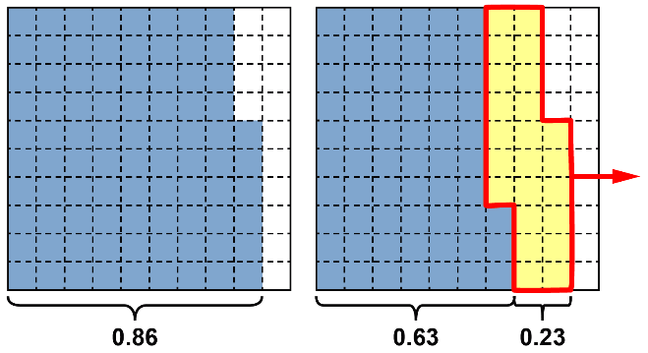  “86 hundredths – 23 hundredths = 63 hundredths  25 – 17 = 8”  (« 86 centièmes – 23 centièmes = 63 centièmes. »)  25.86 – 17.23 = 8.63
Observations/Documentation

Conceptual Meaning of Addition and Subtraction of Decimals (cont’d)
Uses an understanding of place value to add or subtract decimals with hundredths (e.g., using standard algorithm)  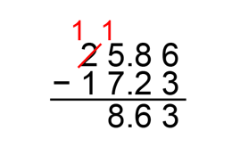  “I used the standard algorithm to subtract  the hundredths, then the tenths, and then  the whole numbers.”  (« J’ai utilisé l’algorithme usuel pour soustraire les centièmes, puis les dixièmes, et enfin les nombres naturels. ») | Uses estimation and mental math strategies to check reasonableness of solutions  25.86 – 17.23 = 8.63  26 – 17 = 9  “8.63 is the answer I calculated,  and it is close to 9,  so my answer is reasonable.”  (« Ma réponse est 8,63, et elle est proche de 9, donc ma réponse est raisonnable. ») | Solves addition and subtraction problems flexibly, using a variety of strategies  A yoyo costs $7.35.  Jesse paid for it with $10.  How much change did Jesse get back?  $7.35 + $0.15 = $7.50  $7.50 + $0.50 = $8.00  $8.00 + $2.00 = $10.00  $2.00 + $0.50 + $0.15 = $2.65  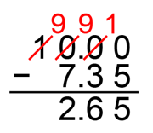  “Jesse got $2.65 back.”  (« Jesse a récupéré 2,65 $. »)
Observations/Documentation

