Determining Multiples and Factors
Uses skip-counting or repeated addition to find multiples  4, 8, 12, 16, 20, …  “To find multiples of 4, I skip counted by 4.”  (« Pour trouver les multiples de 4, j'ai compté par bonds de 4. ») | Uses familiar basic facts to identify some multiples and factors  2 × 4 = 8  3 × 4 = 12  10 × 4 = 40  “I thought of the multiplication facts for 4  that I know.”  (« J'ai pensé aux faits de multiplication de 4 que je connais. ») | Uses efficient strategies to determine multiples and identify all factors  “To find factors of 8, I start  8 ÷ 1 = 8  Factors are 1 and 8.  8 ÷ 2 = 4  Factors are 2 and 4.  8 ÷ 3 = X  8 ÷ 4 = 2  So, 1, 2, 4, and 8 are all factors.”  (« Pour trouver les facteurs de 8, je commence par  8 ÷ 1 = 8  Les facteurs sont 1 et 8.  8 ÷ 2 = 4  Les facteurs sont 2 et 4.  8 ÷ 3 = X  8 ÷ 4 = 2  Donc, 1, 2, 4 et 8 sont tous des facteurs. »)
Observations/Documentation

Determining Multiples and Factors (cont’d)
Uses concrete materials to identify prime and composite numbers  “7 is prime because it has only 2 factors, 1 and 7. 12 is composite because it has more than  2 factors: 1 and 12, 2 and 6, and 3 and 4.”  (« 7 est un nombre premier parce qu'il n'a que 2 facteurs, 1 et 7. 12 est un nombre composé parce qu'il a plus de 2 facteurs : 1 et 12, 2 et 6, et 3 et 4. ») | Identifies common multiples/factors and greatest common factor for a pair of numbers  Factors of 24: 1, 2, 3, 4, 6, 8, 12, 24  Factors of 56: 1, 2, 4, 7, 8, 14, 28, 56  “The greatest common factor is 8.”  (« Le facteur commun le plus grand est 8. ») | Solves problems involving common factors and multiples  “Choir practice is every 5th day.  Gymnastics is every 3rd day.  That means choir and gymnastics both happen every 15th day.”  (« La pratique de la chorale a lieu tous les 5 jours.  La gymnastique a lieu tous les 3 jours.  Cela signifie que la chorale et la gymnastique ont lieu tous les 15 jours. »)
Observations/Documentation

Fluency of Multiplication and Division Facts
Recalls and demonstrates multiplication and divisions facts  to 5 × 5  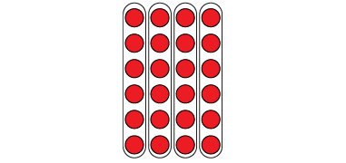  “I know that 4 × 6 = 24  and that 24 ÷ 6 = 4.  The array shows both facts.”  (« Je sais que 4 × 6 = 24 et que  24 ÷ 6 = 4. La matrice montre les deux faits. ») | Uses inverse operations to solve multiplication and division problems  “I can rewrite 24 ÷ 6 = ?  as 6 × ? = 24.”  (« Je peux réécrire 24 ÷ 6 = ? comme 6 × ? = 24. ») | Uses known facts to determine unknown facts  “I can use the distributive property to split the multiplication into facts that I know, then add.”  (« Je peux utiliser la distributivité pour diviser la multiplication en faits que je connais, puis additionner. »)  5 × 9 = 5 × 5 + 5 × 4  25 + 20 = 45  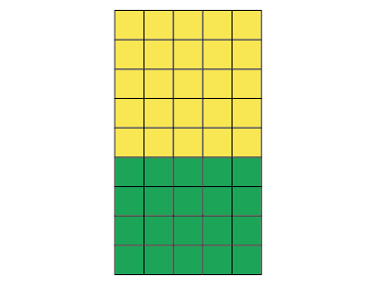 | Fluently creates and solves whole number multiplication problems with factors to 12 and related division problems  There are 96 basketballs with  the same number on each of  12 shelves.  (Il y a 96 ballons de basketball avec le même nombre de ballons sur chacune des 12 étagères.)  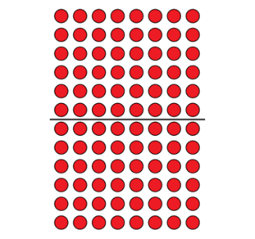  12 × □ = 96, so 96 ÷ 12 = □  12 × 8 = 96  Or  12 × 8 = 6 × 8 + 6 × 8  = 48 + 48  = 96
Observations/Documentation

